Creating Collaborative Subject Guides for Multi-Institutional Digital Collections:

A Case Study from the Louisiana Digital Library
Leah Powell Duncan and S.L. Ziegler, LSU Libraries

Abstract
This case study focuses on the development of subject guides for the Louisiana Digital Library (LDL), a state-wide digital repository for digital cultural heritage. While subject guides are always important for navigating large collections, during the state-wide shutdown of libraries due to the COVID-19 pandemic, the need for the guides was greater than ever. In keeping with the LDL’s multi-institutional and collaborative nature, representatives from seven Louisiana-based institutions responded to an open call to form a rapid-response working group. Within three weeks, ten guides were developed and published. Equally important, an iterative workflow for building and updating guides was established to allow flexible, responsive guides and input from a wide range of professionals and patrons.
Keywords: digital libraries; subject guides; collaborative workflows; pandemic; institution closures

Introduction
In the first two weeks of March 2020, academic institutions across Louisiana closed due to the COVID-19 pandemic, leaving many educators with the daunting task of restructuring their courses for a remote format. One effect of the shutdown was that educators and students could no longer visit libraries and archives in person, a key aspect of many humanities courses. Librarians and archivists at LSU responded quickly by creating subject guides for specific courses that were scheduled to visit our special collections. These guides listed course-specific collections and items that students could find on the Louisiana Digital Library (LDL) in place of seeing relevant materials in person. After providing specific guides to a couple of courses, we decided to develop more general guides to popular research subjects. Building guides for the LDL has long been a goal, but COVID-related closures of physical collections greatly exacerbated the need and expanded the audience.
Over the course of approximately three weeks, the authors assembled an LDL Subject Guide Working Group composed of six digital library professionals from six different Louisiana institutions and developed, not only a set of ten guides, but also the workflow and documentation that allows this project to be collaborative, iterative, and to take advantage of distributed expertise. Aside from providing new ways to engage with the LDL’s unique materials, these guides have provided a means for us to strengthen connections with our colleagues, such as liaison librarians, as well as community members, such as public school curriculum developers. We created a resource that is useful to a broad audience and will remain relevant over time by prioritizing collaboration over top-down delegation, by making decisions based on the collective expertise of the group, and by ensuring that the project would allow for the development of new guides as new needs inevitably arise.
Literature Review
Subject guides have long been a means for libraries to promote content and offer patrons important access points to the collection. Originally taking the form of printed resources, the adoption of online subject guides began in academic libraries from the earliest availability of library websites. As early as 1999, so many libraries were taking the time to build their own guides, instead of re-using those created by others, that Sara Morris and Marybeth Grimes (1999) found it worthwhile to study “how many libraries...provide Internet-based subject guides to their patrons, how librarians choose which sites to include on the guides, and how librarians maintain those sites” (p. 213). This early study highlights two functions of subject guides; Morris and Grimes write that “Librarians feel the Internet-based subject guides are a good ‘jumping off’ point to the Internet,” and that “Librarians tend to tailor the guides to their schools’ curricula or to perceptions concerning patrons’ needs” (p. 216). Literature on subject guides reflects this double purpose of curating internet-wide resources and organizing a specific insitution’s holdings, but studies on both types of guide are relevant here. The LDL Subject Guides are locally focused, offering tours of our specific holdings, but as guides to a digital library they share some features with more general lists of internet resources at large.
While Morris and Grimes (1999) explored how many libraries created subject guides and what their purposes were, more recent library literature on subject guides explores: (1) the overall value of guides as a library resource, (2) characteristics that make individual guides more or less effective, and (3) the difficulties of maintaining a guide’s initial effectiveness over time. Regarding the overall value of guides, Rebecca Jackson and Lorraine Pellack (2004) note that they serve as research aids for users, and that they are also often found internally useful. Librarians will use the subject guides created by their colleagues to answer users’ questions, or as a starting place for their own exhibits. In “LibGuides and Librarians: Connecting Content and Community,” Cindy Judd and Nicole Masica Montgomery (2009) write that subject guides additionally become a marketing tool for the library, serving as another branded touchpoint for users.
Despite these possible benefits, authors also question the value of time spent creating and maintaining subject guides. Jackson and Pellack (2004) studied guides at 112 libraries, noting that librarians often reinvent the wheel by linking to a “large percentage of unique resources that would likely have been of use to any other institution's program,” and relinking resources available on numerous guides across the internet (p. 323). This redundancy may be justified when librarians customize their guides to their institution’s specific resources and curricular needs, and if those guides are in fact used. Jackson and Pellack write, “Librarians are not only trying to create some order out of the chaos of the Internet, but they profess to create unique guides specific to their particular users and their needs,” but they also note, “[M]aybe there is no real need for a guide that receives little use” (p. 319; p. 326). Indeed, librarians have no shortage of work to do and should weigh the time they spend creating resources against the usage those resources receive.
Identifying the characteristics that make subject guides effective also constitutes a primary place in the literature. In her study, Jennifer Little (2010) borrows from cognitive load theory to argue that librarians should create clearly organized guides that minimize the cognitive work researchers must perform to understand the resource before they can meaningfully benefit from it. Little specifically suggests providing “clear descriptions of each research guide’s purpose and for each resource listed in the guide” (p. 10). Additionally, researchers find that guides that are intuitively organized are more effective than those that are not. Rebecca Jackson and Kristine K. Stacy-Bates (2016) write that most literature on research guides agrees “on the separation of resources into categories and the arrangement of resources within those categories,” and they go on to explain that arrangement by relevance within categories has supplanted the popularity of alphabetical arrangement (p. 220). A further question related to effectiveness pertains to whether guides should include full URLs in addition to hyperlinked descriptive text. While Jackson and Pellack (2004) write “some standards should be maintained by all libraries [and one such standard is that] URLs should be included with links” (p. 326), others note that users are increasingly less likely to print guides, and that users who are working from a printed guide would often prefer “to find the resource by name with a general search engine than to risk the possibility of errors in typing long URLs” (Jackson and Stacy-Bates, 2016, p. 223).
Subject guides that are clearly organized and effectively annotated still require ongoing maintenance. Jackson and Pellack (2004) note that even when guides are kept relevant with regular updates and additions, their original organizational framework tends to disintegrate. They found in their study of guides at 112 libraries that 61 percent of guides were in alphabetical order, 30 percent were not, and for the remaining 9 percent “sources started out in alphabetical arrangement, but it appeared that as links were added, the arrangement broke down” (p. 322). Consistent maintenance is required to avoid another common blight of subject guides: dead links. These reduce the credibility of the resource and deter users from continuing to explore. Jackson and Pellack note that keeping track of URL changes to avoid dead links is “important and time-consuming” (p. 324).
In addition to the challenges of preserving a guide’s integrity and currency, guides must be continually promoted. Dana Ouellette (2011) found that students only used subject guides as a “last resort” because students are not aware of them, and they prefer a more familiar search tool such as Google (p. 442). However, Foster et al. (2010) write that students will use subject guides when they are integrated into instruction. In their paper “Marketing Research Guides: An Online Experiment with LibGuides,” Foster et al. studied the effectiveness of various marketing strategies on guide use and found that, “The more a librarian teaches, the more their guide will be used regardless of whether they instruct students to visit the site during a library workshop” (p. 608). While students are not likely to search for subject guides, if made aware of them, some students will return to them.
A final discussion that recurs in subject guide literature is around the benefits of using LibGuides as a web host. LibGuides is popular in libraries. In their article “LibGuides and Librarians: Connecting Content and Community,” Judd and Montgomery (2009) describe their library’s adoption of the product and write that the platform provided them “more purposeful searching of subject-appropriate resources” (p. 16). Jackson and Stacy-Bates (2016) provide a list of reasons librarians choose to use LibGuides, including the platform’s flexibility, ability to host multiple content types, built-in link checker, and inclusion of statistical analysis. However, Jackson and Stacy-Bates claim, the most likely reason libraries use LibGuides is that the product does not require librarians to learn HTML, and it allows them to create web content without involving local technology systems staff (p. 221).
Contrastingly, in her 2014 Codex President’s Column, “Friends Don't Let Friends Use LibGuides,” Karen Niemla argues that the subscription cost of LibGuideswould be better invested in educating librarians on web publishing. “I don’t want to enrich publishers,” she writes, “I want to enrich librarians” (p. 13). Beyond the cost, Niemla argues that LibGuides damage the marketing potential of a subject guide by overwriting the institution’s own branding. She also argues that using a product like LibGuides is risky because “it means that all the content you create will be within that system and you lose your freedom to leave it easily” (p. 15). The authors of this paper make no statement as to the general use of LibGuides, though as we discuss below, the decision to build the LDL Subject Guides as pages on the LDL site instead of using a third-party service was influenced by the literature discussed in this section.
About the LDL and the Need for Subject Guides
The LDL Subject Guides were long planned, but the emergence of the COVID-19 pandemic exacerbated the need for digital archival materials and encouraged us to work quickly. The guides were designed to alleviate specific challenges users might face when attempting to navigate the Louisiana Digital Library. For example, the homepage of the LDL features two primary means of interacting with material. The first is a search bar that queries the entire digital library. The second is a gallery featuring each contributing institutions’ logo and linking to its collections. This arrangement prioritizes wide searches and broad browsing, functions that work well for many users but can be overwhelming for others.
The LDL includes more than 236,000 images, 70,000 newspaper pages, 100 oral histories, and 104,000 pages of books and manuscripts, contributed by over 30 cultural heritage institutions, so many cross-LDL searches yield hundreds and often thousands of results. These results can be filtered by subject, creator, form, and date, but inexperienced and casual users may not be proficient in employing these search tools. Additionally, the institution-specific browse feature is not likely an intuitive access point for users who do not know which institutions hold material that will interest them. For example, a user coming to the LDL looking for material on the twentieth-century Louisiana politician Huey Long will, when using the search bar on the homepage, see a return for over 39,000 items. These items include photographs of Huey Long the person, but also photographs of the bridges named for him, monuments to him, and lesson plans prepared for classes that teach about him. While experienced researchers with time and expertise can gather much from such returns, there are many users who will be daunted by this number of results. Likewise, the same user wouldn’t know which institutional collections to browse in order to find material related to Huey Long.
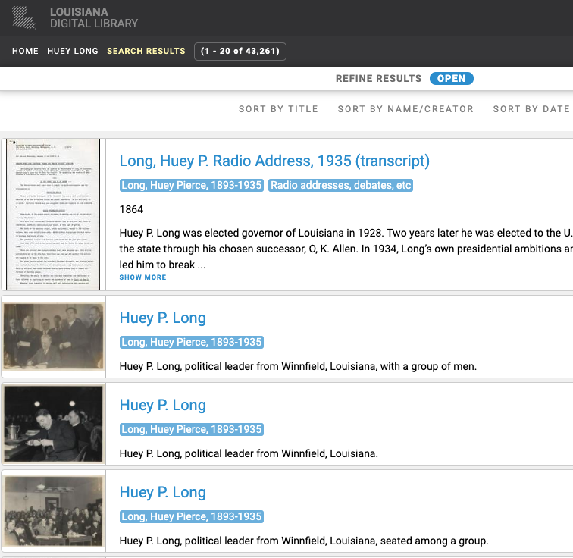
LDL-wide search on 13 Aug 2020 for “Huey Long,” showing 43,261 results
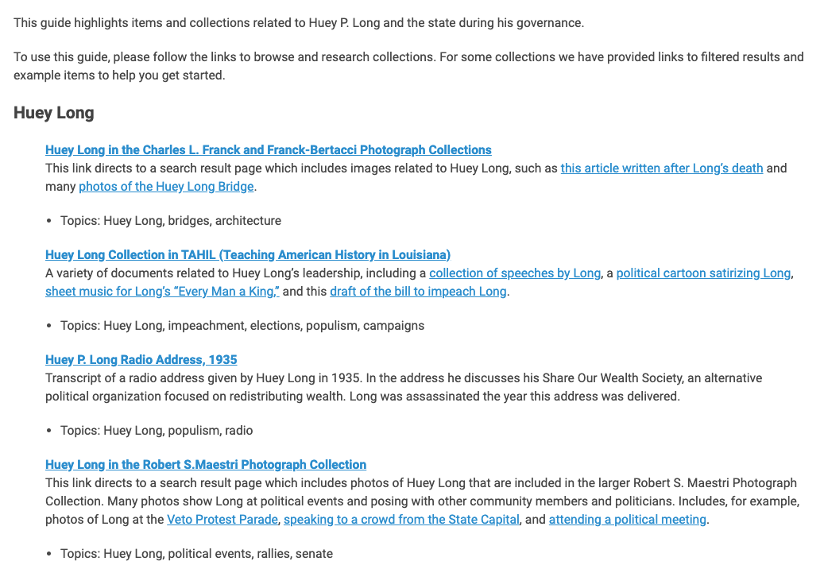
Part of the LDL Subject Guide to Huey Long
The LDL Subject Guides provide a more structured way to explore the digital library. Users bypass both the search results that overwhelm and the institution-specific browse that often assumes a deep knowledge of specific library holdings. The guides provide curated cross-institutional tours of popular research topics, and casual users can use the guides to browse a subject, confident that they are viewing some of the digital library’s most relevant items. Users with defined research agendas can use the guides as a diving board into a topic and explore other facets independently.
Building Guides the LDL Way: Collaboration, Distributed Expertise, Iteration
We knew from this project’s inception that we wanted it to be shaped by collaboration with librarians and archivists from as many LDL contributing institutions as possible. Although LSU Libraries maintains the technical framework of the LDL, professionals at contributing institutions are experts in their own collections, as well as in their own users’ needs. To create guides that are effective across institutions and audiences, it was necessary to leverage that expertise. The first step to building the guides was to put out a call to LDL participating institutions. Professionals from six different institutions--Delgado Community College, Louisiana State Archives, LSU Shreveport, Loyola University New Orleans, the State Library of Louisiana, and Southern University--expressed interest and, together with the authors of this article, formed the core LDL Subject Guide Working Group.
The second step was to convene a remote meeting, during which we discussed the broad goals of the project, and members of the team shared local user needs and local collection strengths. From this distributed expertise, in which each participant was encouraged to take ownership over the needs at their local institution, arose the desire to ground some of our subjects in K-12 Louisiana Student Standards in order to ensure the widest possible use of the guides and collections. The working group was lucky to have some expertise in this area in the person of Sarah Mazur, Head of Resource Description and Discovery at LSU Shreveport. Mazur has experience as a primary school teacher and familiarity with Louisiana teaching standards, and she was also able to provide guidance in contacting educators in different parishes. Mazur examined the Louisiana Student Standards for Social Studies and identified learning objectives that could be matched with historical subjects and themes represented in the LDL. We used this information to decide for which subjects to prioritize guides. Often the primary audience for the LDL is considered to be college-level students and professional researchers, but we know that this is a self-fulfilling expectation: when interfaces are created with the assumption of specific audiences, other possible audiences encounter inadvertent technical challenges to using the tool. By building the guides to correspond to the student standards, we are making a concerted effort to widen the impact of the LDL.
In addition to collaboration and distributed expertise, iteration is also important for the guides. We knew that to act quickly and to be as effective as possible, we should build from work that had already been done. To that end, we referenced a set of lesson plans compiled during a grant-funded project in 2007 titled Louisiana Gumbo: A Recipe for Empowerment. This thirteen-year-old set of lessons was designed to lead students in engaging with LDL content, but over the years all of the links broke due to an LDL platform migration. Additionally, student standards have since shifted and, of course, no LDL collections ingested since 2007 were included in the lessons. There is much to admire in these lesson plans, and after accounting for new links we were able to reuse many of the collections the grant team originally gathered.
Iteration is also centered in our focus on documenting workflows to ensure that current and future professionals can easily add new guides to the LDL page, as well as add new items to extant guides. We now have the frameworks in place to seamlessly include additional LDL participants in the project without holding frequent meetings to discuss details. We supplemented this documentation with an LDL web form where users can recommend subjects for new guides. After all, we do not expect any working group to be able to think of all possible options. By creating sustainable workflows and a recommendation form, we will be able to continually develop the LDL Subject Guides based on distributed professional knowledge alongside community input.
The Workflow
We focused on establishing clear guidelines that foregrounded the three principles of our work: collaboration, distributed expertise, and iteration. Prioritizing these principles allowed us to work efficiently with a team spread across Louisiana, and to thereby launch the first set of guides quickly--within a three weeks of our first remote meeting--in order to best serve the needs of students and educators unable to visit our physical holdings.
After initial working group discussions, the first author chose 10 subjects for the first set of guides based both on the K-12 Louisiana Student Standards as well as input from the working group members. These original 10 subjects are: 18th & 19th Century Maps; Civil Rights Movement; Cultural Perspectives in the Arts; Environment; French Colonization & Early Statehood; Highway Systems & Infrastructure; Huey P. Long; Mississippi River; Slavery & Civil War; World War II.
We used a Google spreadsheet to allow each working group member to claim one or more of the subjects for which to develop a guide. We were open to multiple members working jointly on a guide, but that ultimately did not happen. After claiming a subject, each member was encouraged to use the following workflow. The first step was to look at the Louisiana Gumbo: A Recipe for Empowerment project to find similar subjects represented there. For example, the librarian developing a new guide on WWII would find that Louisiana Gumbo includes lesson plans on “World War II Projects” and “Women in World World II.” The next step was to find updated LDL links for the collections listed in the relevant Louisiana Gumbo lesson plans. For example, the “Women in World War II” lesson plan directs users to the “America at War” LDL collection, but the provided link is dead. Finding the new link was simply a case of searching for the collection name from the LDL homepage search bar. By taking advantage of the important work done in the Louisiana Gumbo project we were able to find the same collection in the current LDL, and add it to the new guide.
However, developing the LDL guides involved more than simply updating dead links from old guides. As mentioned above, much content has been added to the LDL since 2007. To account for this, the next step was to build beyond the Louisiana Gumbo project by finding additional collections and items. This was done either by starting with simple searches and following the subject facets from search returns, or by relying on the specific expertise of the working group members.
Additionally, we recognized that many collections are quite large, and will contain items of interest to several subject guides. For example, the Center for Louisiana Studies Archive collection contains 1,237 items documenting 64 parishes, as well as illustrations of the state from magazines such as Harper’s Weekly. In this case, rather than direct users to the entire Center for Louisiana Studies Archive collection, we provided links to filtered search result pages that highlight items relevant to the given subject. The Center for Louisiana Studies collection contains approximately 130 photographs of the 1927 Flood that would be relevant on the “Environment” subject guide. The link in the guide under the header for Center for Louisiana Studies Archive collection leads to this search return rather than to the general collection landing page.
The authors made the decision to host the guides as pages on the LDL, instead of using a third-party service such as LibGuides. This decision allowed us to integrate branding seamlessly, as well as tightly connect the guides to the digital library as a whole. We find that, much as Judd and Montgomery (2009) pointed out, the subject guides become a type of marketing tool for the library in addition to a hub for strengthening relationships both within our campus communities and beyond. Like many librarians in academic settings, the authors rely on liaison librarians to promote the guides to academic departments. This has consequently provided an opportunity to update our colleagues about the LDL as a resource. In response to receiving information on the guides, Brittany O’Neill, LSU Libraries Humanities and Social Sciences Librarian, wrote, “I'm always trying to encourage my faculty and students to use the LDL more, but it helps to break up the topics covered to give them a better idea of its content and how it could be used” (personal communication, May 12, 2020). Indeed, building partnerships with our colleagues in different departments has been particularly important during the COVID-19 pandemic, as we are eager to give our campus constituents a better idea of our online content and how it can be used. Beyond campus, the guides have given us a way to connect with local K-12 educators. One ongoing goal for the LDL is to reach a broader audience of primary and secondary education teachers and students. A first step in this direction is to make K-12 teachers aware that the LDL allows students to view our state’s historical primary resources from their classrooms and homes. Early efforts in this initiative have included workshops to demonstrate the use of the LDL as a teaching tool for information and data literacy alongside humanities content. These workshops included informal discussions in which teachers expressed excitement at the idea, but hesitation at the ability to curate relevant links from the vast amount of content. The LDL guides build on these conversations and help us solidify partnerships with aspirational audiences.

Conclusion
There are significant obstacles to developing and sustaining subject guides, such as ensuring the guides are relevant to a library’s users, ensuring that users know about the guides, and maintaining the guides’ currency and organizational integrity. The guides we have built are certainly not immune to these challenges and will only stay useful if we can keep them active. We hope that we’ve put them on sound foundation by collaborating with professionals across the state, relying on distributed knowledge about specific collections and users, and developing frameworks that allow the project to be iterative and the subject guides to be in continual development. We have also used the guides as a way to connect with colleagues and community members and inform them about LDL content and its uses. Though long planned,the COVID-19 emergency was the catalyst to begin this work. Writing as the emergency continues, the authors are quick to admit the future is uncertain. However, it is our hope that the guides serve in some way to promote the unique digital heritage culture of Louisiana for current and future students, researchers, and community members. We hope that these guides will not only be a resource for our users during and after pandemic-related closures, but also a way for more people to become a part of the LDL community.

References
Foster, M., Wilson, H., Allensworth, N., & Sands, Diane T. (2010). Marketing research guides: An online experiment with LibGuides. Journal of Library Administration, 50(5), 602–616. https://doi.org/10.1080/01930826.2010.488922
Jackson, R., Pellack, L. J. (2004). Internet subject guides in academic libraries: An analysis of content, practices, and opinions. Reference and User Services Quarterly, 43(4), 327-35. http://lib.dr.iastate.edu/refinst_pubs/14
Jackson, R., Stacy-Bates, K. K. (2016). The enduring landscape of online subject research guides. Reference and User Services Quarterly, 55(3), 219-29. https://doi.org/10.5860/rusq.55n3.219
Judd, C., Montgomery, N. M. (2009). Libguides and librarians: Connecting content and community. Kentucky Libraries, 73(3), 14-7.
Little, J. (2010). Cognitive load theory and library research guides. Internet Reference Services Quarterly, 15(1), 53-63. https://doi.org/10.1080/10875300903530199
Morris, S. E., Grimes, M. (1999). A great deal of time and effort: An overview of creating and maintaining internet-based subject guides. Library Computing, 18(3), 213-16.
Niemla, K. (2014). President’s column: Friends don't let friends use LibGuides. Codex: Journal of the Louisiana Chapter of the ACRL, 3(1), 9-20. http://journal.acrlla.org/index.php/codex/article/view/96
Ouellette, D. (2011). Subject guides in academic libraries: a user-centred study of uses and perceptions. Canadian Journal of Information and Library Science, 35(4), 436–451. https://doi.org/10.1353/ils.2011.0024

The original LDL Subject Guide Working Group members are: Charlene Bonnette, Head of the Louisiana Department, State Library of Louisiana; Caitlin Cooper, Coordinator of Collection Development, Management, and Acquisitions, Delgado Community College; Kure Croker, Special Collections Registrar & Archivist, Monroe Library at Loyola University; Sarah Mazur, Head of Resource Management and Discovery, LSU Shreveport; Angela Proctor, University Archivist, Southern University; Heaven Smith, Archives Specialist, Louisiana State Archives; and the authors of this paper.
Thanks to the State Library of Louisiana, at the time of this writing, the original lesson plans are still available at: http://www.state.lib.la.us/about-the-state-library/publications/louisiana-gumbo-a-recipe-for-empowerment. Special thanks to Charlene Bonnette for informing us about this resource.
For more information on this: https://louisianadigitallibrary.org/blog/ldl-connects-humanities-amped

