What’s That Smell? Managing Deteriorating Microfilm Collections
in Libraries and Archives
Heather Plaisance, University of Louisiana at Lafayette
Abstract
The use of microphotography in libraries has its roots in the 1930s and 1940s. Microforms have served many functions within libraries and archives, primarily to save space and preserve scarcely used or rare materials. While the benefits to libraries are substantial, unfortunately microform materials are susceptible to damage and deterioration over time, resulting in a tremendous loss of information in libraries and archives across the world. Unfortunately, once damage to microforms occurs, it cannot be stopped, just slowed. This article discusses the efforts at the University of Louisiana at Lafayette’s Edith Garland Dupré Library to manage significant damage to its microform holdings. Based on personal experiences and rooted in practices documented in the research literature, the author identifies best practices and remediation options for managing deteriorating microform collections in libraries and archives.
Keywords: microfilm; microfilm deterioration; vinegar syndrome; collection management (libraries)

APA 7th edition citation
Plaisance, H. (2021). What’s that smell? Managing deteriorating microfilm collections in
libraries and archives. Codex, 6(1), pp. 77-95.
Introduction
Since its development in the nineteenth century, microphotography has been used for a variety of purposes. In 1839, English scientist John Benjamin Dancer began experimenting with the technology and later “sold microphotographs as slides to be viewed under a microscope” (Canepi et al., 2013, Historic Overview section). In the 1920s, the Checkograph machine, developed by banker George McCarthy, was designed to make copies of banking records on film for permanent storage (Canepi et al., 2013). Microphotography has also been used in times of war. During the Franco-Prussian War, carrier pigeons flew microfilmed messages across enemy lines into Paris. During World War II, the Victory Mail system used microphotography to transport personal and official messages to the U.S. soldiers stationed overseas (Canepi et al., 2013).
During the 1930s, the use of microphotography in libraries as a preservation tool gained strength, and in 1936, the American Library Association adopted microforms as an accepted information storage method (Westcott, 2017). Two years later, Harvard University adopted the technology to preserve the foreign newspapers in their collections as part of their Foreign Newspaper Microfilm Project (Simon, 2006). In 1938, University Microfilms International expanded their offerings to libraries when it began microfilming doctoral dissertations (Canepi et al., 2013). After World War II, concerns over the possible destruction of irreplaceable cultural materials and archives led to organized microfilming preservation projects across the United States (Canepi et al., 2013).
Throughout the twentieth century, several factors contributed to the growth of library microform collections. In the 1950s and 1960s, newly developed “uniform testing standards by the Library of Congress (LC), the availability of grant funds for both production and purchase, and the introduction of reprographic equipment by companies such as Xerox and Kodak” (Canepi et al., 2013, Historic Overview section) contributed to the widespread acquisition of microforms by libraries and archives. In the 1970s, it was “new standards, the passage of a new copyright law, and the appearance of cheaper, higher-quality film types” (Canepi et al., 2013, Historic Overview section) as well as the emergence of micropublishers. Finally, the National Endowment for the Humanities-funded Brittle Books Program and United States Newspaper Project in the 1980s and 1990s played a role in the continued integration of microforms into library collections.
Microforms have served many functions within libraries and archives, primarily to save space and preserve rare materials. While the benefits to libraries are substantial, unfortunately, microform materials are susceptible to damage and deterioration over time, resulting in a tremendous loss of information. This article discusses the efforts at the University of Louisiana at Lafayette’s Edith Garland Dupré Library to manage significant damage to its microform holdings. Based on personal experiences and rooted in practices documented in the research literature, the author identifies best practices and a number of remediation options for managing deteriorating microform collections in libraries and archives.
Microform Composition

To take advantage of the growing microphotography industry of the twentieth century, microform vendors began developing many different products. These included “hybrid microform solutions including aperture cards, micro-opaques, ultrafiche, jacket fiche, diazo, vesicular and silver technologies” (Westcott, 2017, p. 2). While many were not as popular, libraries and archives everywhere incorporated microfilm and microfiche materials into their collections. Westcott (2017) notes: “So began the creation of billions of microfilm reels and custom microforms containing trillions of images of document pages'' (p. 2).
Regardless of the format, all microform materials consist of three components: “a base, an emulsion and a binder that adheres the emulsion to the base” (Canepi et al., 2013, Composition of Microfilm section). Several film bases have been used in microform production. Early films were produced using a cellulose nitrate base. However, by 1950, that practice was discontinued due to cellulose nitrate's tendency to spontaneously combust when improperly stored (Westcott, 2017). The use of acetate film became the norm from the 1950s to the mid-1980s. While safer than cellulose nitrate, acetate-based materials, it was later discovered, are highly susceptible to deterioration. The deterioration of acetate materials will be discussed in more detail later in this article. Today, polyester-based film is standard in microfilm production because it is chemically stable and durable (Canepi et al., 2013).
The emulsion layer contains the film's image, with the most used emulsions being silver halide, diazo, and vesicular. Silver halide microfilm features grains of silver suspended in gelatin and is recommended for preservation copies because it creates the most exact reproductions (Canepi et al., 2013). Silver halide film has a life expectancy of 500 years if stored properly. Diazo emulsions use "diazonium salts in the film emulsion combine with dye couplers to produce strong, dense colors" (Institute of Museum and Library Services, n.d., Diazo Microfilm section). The diazo film will quickly fade upon exposure to light, making it unsuitable for rare and irreplaceable materials. Vesicular microfilm uses heat to form bubbles that remain after cooling to create the image and is vulnerable to extreme heat (Institute of Museum and Library Services, n.d.).
History of Microforms at Edith Garland Dupré Library

The Microforms Department (Microforms) at the University of Louisiana at Lafayette’s Edith Garland Dupré Library houses most of the library’s microforms collection. Over the years, the department has shifted within the library’s organizational chart. In the 1980s and 1990s, Microforms functioned as part of the Public Services’ Reference Support Services Department. After a reorganization of library departments and personnel in 2000, the department moved under the Special Collections umbrella. In 2018, following the department head’s retirement after 47 years, Microforms moved under Reference and Research Services' direction. Today, the Microforms Library Specialist Supervisor and the Head of Reference and Research Services oversee the department’s operations.
Originally located on Dupré Library’s second floor, Microforms moved to its current first-floor location after building renovations were completed in 2000. A review of annual reports shows the library’s microforms collection had steady growth from 1978 to 2005. At its peak, Dupré Library housed two million microform units in both Microforms and Special Collections. The library’s collection features formats, including microfilm, microfiche, and microcard. Resources include state, national, and international newspapers, popular and scholarly periodicals, and documents and reports from many federal government agencies.
An examination of the usage of Dupré Library’s microforms collection from 1980 to 2020 reflects the trend of information moving from predominantly print-based to electronic format. Statistics included in library annual reports from 1980 to 1999 show 436,815 recorded uses of items in the microforms collection. As more information became accessible on the Internet and the library began to provide electronic databases as research tools, microforms usage dropped substantially. From 1999 to 2020, usage was down to 48,334, representing an 89% decrease from the previous nineteen years. The library's closure during most of 2020 in response to the COVID-19 pandemic resulted in a dramatic drop in microform collection use with a total of 23 from January to July.
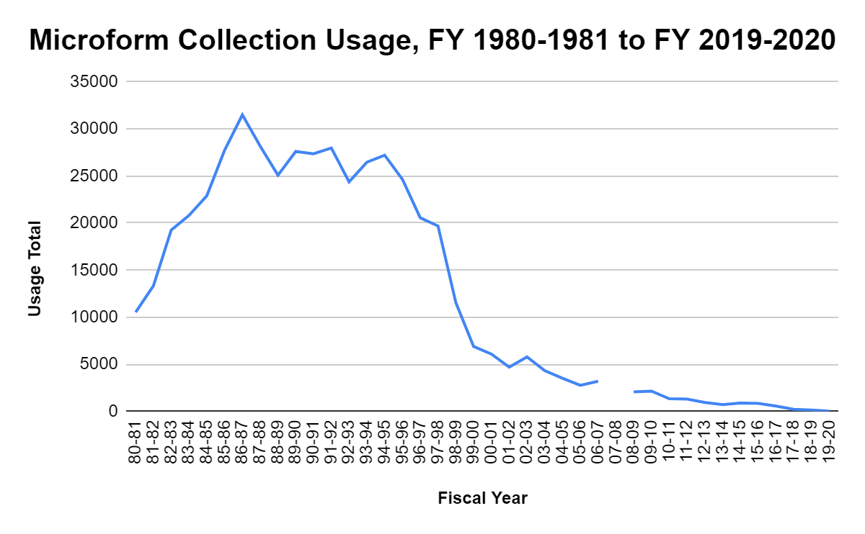
**Annual Report not available FY 2007-2008.

Aside from the electronic availability of newspapers and periodicals, other reasons explain the decline of microforms usage at Dupré Library. Perhaps the most influential was the discard of the library’s Daily Advertiser holdings on microfilm due to extreme deterioration, first partially in 2016 and then completely in 2018. Dupré Library was the only library in the Acadiana area that housed the Daily Advertiser backfiles from the late 1860s to the mid-2000s. For decades, users from the community requested articles and obituaries published in the newspaper. With its holdings now gone, the library could no longer fulfill these once-popular requests. Another contributing factor to the decline in microforms usage was the retirement of a UL Lafayette history professor who required her students to use historical resources, many of which were only available on microfilm, to complete class assignments. Lastly, a reduction in undergraduate students using the collection to complete scavenger hunts instructing them to print the front page of a newspaper published on the day they were born has been noted by library staff for the last several years.
Signs of Microfilm Deterioration

Evidence of microfilm deterioration at Dupré Library was reported as early as the 1999-2000 fiscal year, starting a pattern that continues decades later. Bethard (ca. 2000) wrote, “Serious consideration needs to be given to replacing some of our backfiles of the New York Times” (p. 2). At that time, Bethard (ca. 2000) noted a deterioration in the New York Times reels primarily containing dates from the 1940s. In 2001, the continued decay of the New York Times was reported again. Additionally, Bethard (ca. 2001) wrote about the same issues in the Daily Advertiser holdings containing dates from the 1950s, saying, “the same type of deterioration in its beginning stages has been noted” (p. 2).
The Microforms annual report for the 2003-2004 fiscal year again mentions continued film deterioration. Requests to purchase replacements for the damaged film were made, but budgetary constraints did not always allow for such purchases (Bethard, ca. 2004). The deteriorating film remained in place, and three years later, Bethard (ca. 2007) again sounded the alarm, writing, “badly damaged acetate films in the backfiles of the Daily Advertiser and the New York Times continue to be discovered” (p. 2). By 2013, both newspapers' holdings were “damaged by vinegar syndrome to the point of being illegible” (Bethard, ca. 2013, p. 1). After years of little to no remediation, the film had become warped and brittle to the point of breaking when loaded onto a microfilm reader or unrolled from the reel.
The author began working at Dupré Library in 2005. At that time, a strong, vinegar-like odor permeated the area near the cabinets housing the New York Times and Daily Advertiser microfilm holdings. The scent was so pronounced, it could be smelled without needing to open the cabinet drawers. It was clear an active state of deterioration due to vinegar syndrome was occurring. By 2018, the damage had become so extreme little could be done to save the collection resulting in the loss of centuries' worth of information.
Vinegar Syndrome in Acetate-Based Microforms

Selle (2003) states that “acetate film base is a modified form of cellulose with an inherent tendency to degrade” (p. 2). Once the material's chemical composition starts to break down, acetic acid forms and begins to emit a vinegar-like odor, which eventually causes the film to degrade. This deterioration is commonly known as vinegar syndrome. According to Reilly (1993), acetate film starts degrading once levels reach 0.5 free acidity. However, there may be no visible signs of deterioration at this stage. In extreme cases of vinegar syndrome, the film’s base layer begins to shrink, resulting in “warping, curling, buckling, embrittlement, and blisters (also called channels) to appear on the film” (Selle, 2003, p. 2). It is important to note that while acidity levels will gradually build over time, the film enters a state of rapid deterioration once the 0.5 free acidity threshold is met (Reilly, 1993).
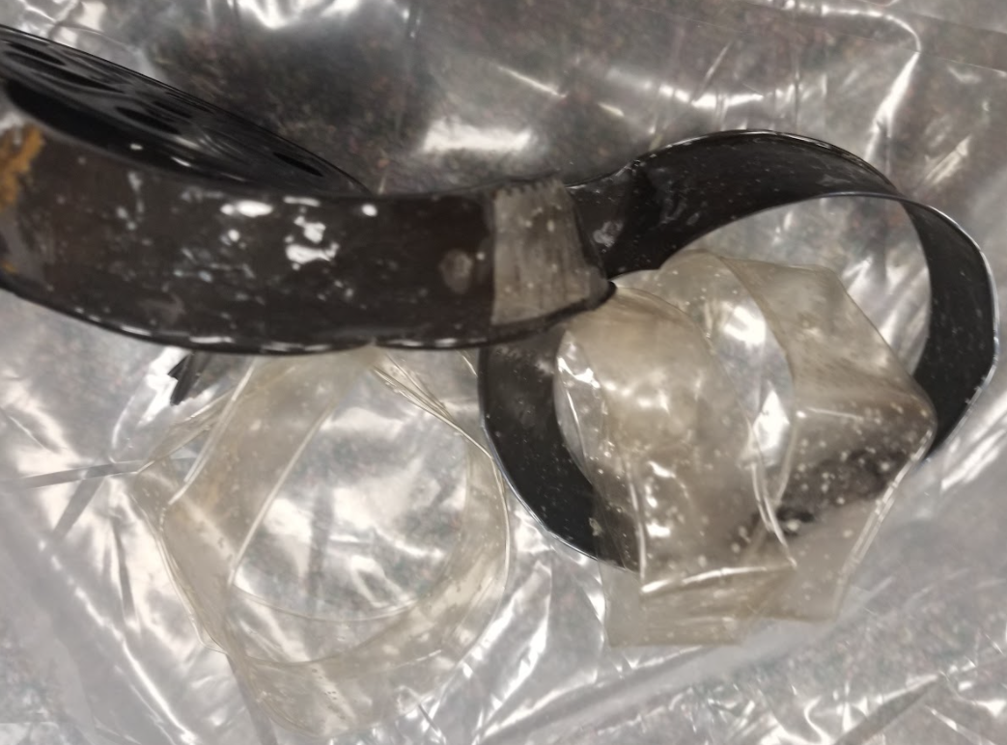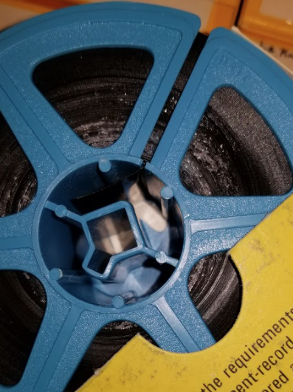
Microfilm damaged by vinegar syndrome
Ahmad (2020) writes, “vinegar syndrome cannot be prevented forever, nor can it be reversed. It can only be delayed” (para. 3). As knowledge of microform technology grew, it became clear that environmental conditions such as temperature and humidity play crucial roles in determining the rate at which acetate film deteriorates. Unfortunately, from 1930 to 1980, when production of acetate-based film both commercially and by in-house library microfilming operations was high, “there was not general recognition that microforms required storage in low-temperature and low-humidity environments for long-term preservation” (Westcott, 2017, p. 2). The result has been a significant and permanent loss of microfilm collections in libraries and archives.
Remediation Efforts to Prevent Material Loss

Vinegar syndrome can quickly spread to other materials. As Ahmad (2020) states, “just one reel of severely degrading acetate film could cause serious damage to the rest of the collection if the vinegar syndrome is not contained” (“Modelling Film Degradation” section). Upon discovering signs of vinegar syndrome, libraries must act quickly to prevent widespread damage to microform collections. While vinegar syndrome will not stop once established, several remediation efforts may extend the life of materials by slowing deterioration and preventing additional material loss.
Identify Deteriorating Materials

Periodic assessment of the physical condition of microform materials can help libraries identify those pieces showing signs of vinegar syndrome and other contaminants such as mold. One way to assess is to conduct a visual inspection of the materials. In 2018, Dupré Library staff began examining holdings of the Daily Advertiser to salvage as many reels as possible due to its importance to the Acadiana area. Staff checked the materials for signs of the vinegar smell, evidence of warping, and mold.
When conducting an assessment project, it is essential to protect staff who handle contaminated materials due to the potential health hazards that acetic acid poses. Prolonged exposure to acetic acid can irritate the eyes, skin, and respiratory system (Virginia Department of Health, 2018). Dupré Library staff working on the project wore protective equipment, including face masks and gloves, took frequent breaks, and worked in a well-ventilated area. Those with respiratory conditions such as asthma did not participate in the film inspection project. To prevent the spread of mold, staff covered the floors and workspaces with plastic sheeting.
Using Acid-Detection (A-D) strips is another method useful in detecting vinegar syndrome in microfilm collections. Developed by the Image Permanence Institute, A-D Strips “provide a simple and safe method for detecting, measuring, and recording the severity of vinegar syndrome” (Image Permanence Institute, 2021, “What are A-D Strips?” section). The strips are placed directly inside boxes or cabinets housing microform materials and change color if acetic acid vapors are present. A-D Strip kits are available for purchase online from the Image Permanence Institute at https://store.imagepermanenceinstitute.org/ad-strips. The kit includes a printed guide featuring “four bands of color, numbered from 0 to 3; these correspond to strip colors at four levels of acidity” (Image Permanence Institute, 2021, “How do A-D Strips Work?” section). The guide also includes recommended actions for remediation at each level.
Isolate Contaminated Materials

Since the contamination caused by vinegar syndrome can quickly spread, “films showing vinegar syndrome should be segregated” (Reilly, 1993, p. 14). This same practice can apply to materials found to have mold growth. If possible, store contaminated film in cabinets away from those that house the remaining collection. After Dupré Library’s Daily Advertiser holdings were deemed unsalvageable, unfortunately, due to the volume of materials and lack of extra storage space, they remained in place until their disposal several months later. The cabinet drawers were labeled to indicate that materials were unavailable for use, and the item record in the online catalog was removed. Staff followed the same procedure with holdings of the New York Times.
After focusing on the most critical materials first, similar physical inspections of The Times-Picayune and The Advocate (Baton Rouge, LA) were conducted. As more contaminated materials were discovered, they were isolated from the rest of the collection based on their condition. Materials showing signs of extreme deterioration or mold were placed in dedicated cabinets on the opposite side of the room, where they awaited disposal. Cabinets containing reels having only a vinegar smell but no physical signs of deterioration or decay were moved to another location within the Microforms Department but away from the remaining collection. These materials are still available for use and are periodically monitored for signs of further damage.
Bigourdan (n.d) states, “the use of cold or subfreezing storage temperatures can postpone further decay of film in critical condition” (p. 3). Cold temperatures “reduces the rate of further chemical changes, thereby stabilizing them until they can be duplicated” (Bigourdan, n.d., p. 3). According to Bigourdan (n.d.), when removing materials from cold storage, care must be taken to “prevent moisture condensation when the film is moved into a warmer environment” (p. 6). Like with other methods, utilizing cold storage will not pause or reverse the damage already sustained to materials but merely provides more time for libraries to investigate film replacement options.
Improve Storage Conditions

When stored properly, polyester-based materials' life expectancy increases to 500 years and 100 years for acetate-based materials (Canepi et al., 2013). Ideally, microform materials' storage conditions should have temperatures not exceeding 70 degrees Fahrenheit and relative humidity levels of 30 percent (Gwinn, 1987). Materials stored at consistently high temperatures make the onset of rapid deterioration likely as the chemical reactions that contribute to vinegar syndrome occur at faster rates (Reilly, 1993). Relative humidity levels determine the amount of water film materials absorb, and as Reilly (1993) states, “the higher the RH, the faster the degradation” (p. 4).
To ensure the health and stability of microform materials, consistency in environmental storage conditions is critical (Gwinn, 1987). For years, Dupré Library has been afflicted by inconsistent temperatures and humidity levels in parts of the building, including the Microforms Department. Starting in May 2004, daily temperature and humidity levels in Microforms were kept. Readings from May and June 2004 indicate a range of temperatures from 70 to 75 degrees Fahrenheit, and humidity ranging from 44 percent to as high as 78 percent (Bethard, ca. 2004). A review of readings from 2005 through 2018 shows the pattern of varying temperature and humidity continued, to the continued detriment of the collection. The library's Special Collections that houses archival materials on microfilm and photograph negatives has also experienced similar temperature and humidity issues. In 2007, the Head of Special Collections wrote, “humidity in the Louisiana Room stacks and the archives stacks varied by 10% or more on over 40% of the readings taken during the year” (Turner, ca. 2007, p. 133). As a result, like Microforms, Special Collections is currently experiencing deteriorating microform materials. It is hoped that the air handler replacement project scheduled for late 2020, early 2021, will finally maintain a consistent temperature and humidity levels throughout the building.
Selle (2003) writes, “to retard deterioration, separate microfilm by base type. Segregate acetate film from polyester-based microfilm and other material” (p. 4). To accomplish this, libraries must first identify acetate-based materials. Besides smelling for vinegar, holding a roll of microfilm up to the light can identify film type (Selle, 2003). “If it is opaque (light does not pass through), the film is likely acetate. If the film is translucent, it is probably a polyester-based film” (Selle, 2003, p. 3). Finally, tearing a small piece of the film can help to identify its base. Polyester-based film is stronger and will not rip, while the acetate-based film will (Selle, 2003).
Investigate Digital Alternatives

Libraries with materials showing beginning signs of deterioration may want to consider digitizing them to prevent further loss. There are several factors libraries should consider before starting a microform digitization project. First, the size of the collection and the availability of funds can determine whether libraries should outsource the project. While commercial digitization services are available, libraries with access to high-quality microfilm scanners may want to consider doing the work in-house. Depending on the volume of materials, this process may be time-consuming and labor-intensive, and libraries completing the work themselves should have a prioritized list of those materials that require digitization. Adequate storage space for digital images on either internal servers or through cloud-based services also needs to be considered. Finally, the quality of the original reel of microfilm is of particular importance as it will determine the quality of the digital image (Canepi, 2013). Digitization, like with other remediation options, will not stop active deterioration. However, it is a way to preserve information while at the same time providing service copies for library users.
When digitizing materials is not possible, libraries should explore other digital alternatives. Many options containing digital access to historical newspapers, books, and other documents are freely available online or via paid subscription. Most notable is the Library of Congress’ Chronicling America (https://chroniclingamerica.loc.gov/), which provides free access to digitized copies of historical newspapers published across the United States. The Internet Archive (https://archive.org/) and HathiTrust (https://www.hathitrust.org/) both feature digitized copies of books and documents and are free to search but may have viewing restrictions that vary by item. Finally, subscription services such as Newspapers.com (https://www.newspapers.com/) provide access to thousands of digitized newspapers from all fifty states and selected countries.
Disposing of Microform Materials

Microform materials should be disposed of using safe and environmentally responsible methods. However, “there is no one centralized method of donation, disposal, and discarding of film” (Canepi et al., 2013, Donating, Discarding, and Recycling section). Before disposing of any materials, Dupré Library staff consulted the UL Lafayette Office of Sustainability for guidance regarding disposal options. After some discussion, the issue was referred to the University’s Office of Environmental Health & Safety. The author and the Associate Director of Public Safety attempted to determine the contaminated materials' manufacturer and production date but were unsuccessful. To not inadvertently throw away hazardous items in the garbage, these, and all future microform materials, are disposed of utilizing the University’s hazardous waste contractor.
Recycling may be an option for disposing of microform materials but depends largely on an area’s vendor availability. “Larger metropolitan areas tend to have a wider range of recycling collections and opportunities'' (Canepi et al., 2013, Discard Safely section). If not available at the local level, the National Association for Information Destruction (NAID) can provide libraries with guidance on the disposal of microform materials. The NAID “focuses on secure data destruction and advocates for a standard of best practices across governments and by service providers as well as product, equipment, and service suppliers globally” (National Association for Information Destruction, 2021). A searchable directory of certified vendors who provide micro-media destruction services is available on the NAID website, https://naidonline.org/. Also, libraries may want to seek guidance from hospitals and other medical providers who dispose of x-ray films or similar medical records (Canepi et al., 2013).
It is important to note that whatever method is used, the disposal process can take time to complete depending on the volume of materials and, most importantly, funding. Libraries that cannot support the project out of their budgets may need to secure funding from other sources. In this case, progress on the project may slow dramatically or stop altogether for extended periods of time. At Dupré Library, because the library’s budget does not allow for this expense, special funding is requested from the University’s Administration and Finance Division. The entire process from identifying contaminated materials to final disposal has been slow and has taken as long as one year. Unfortunately, when funds are not available, the materials remain in place, providing ample time for more damage and information loss to occur.
Conclusion

Microphotography has had a long and varied history. The acquisition of microform materials by libraries provided several benefits for the users and the libraries themselves. With the technology, users could access a wealth of information they may not have been able to otherwise. For libraries, microform products eliminated the need to keep decaying paper materials and save valuable shelving space because of their small footprint. However, microforms introduced the possibility of a devastating loss to library collections due to their tendency to deteriorate over time. Regular maintenance and proper environmental and storage conditions are crucial for the health and stability of microform collections. While deterioration, once established, cannot be stopped, with early intervention and many remediation efforts, libraries can prevent loss and preserve valuable and often irreplaceable information.

References

Ahmad, I. R. (2020, May 19). Historical films may be decaying much faster than we thought thanks to ‘vinegar syndrome.’ The Conversation. https://theconversation.com/historical-films-may-be-decaying-much-faster-than-we-thought-thanks-to-vinegar-syndrome-131712.
Bethard, A. Y. (ca. 2000). Annual report, Microforms Department, 1999-2000. Alvin Y.
Bethard Collection. (Collection 405, Box B, Folder 2-1). Acadiana Manuscripts Collection, Edith Garland Dupré Library, University of Louisiana at Lafayette, Lafayette, LA.
Bethard, A. Y. (ca. 2001). Annual report, Microforms Department, 2000-2001. Alvin Y.
Bethard Collection. (Collection 405, Box B, Folder 2-1). Acadiana Manuscripts Collection, Edith Garland Dupré Library, University of Louisiana at Lafayette, Lafayette, LA.
Bethard, A. Y. (ca. 2004). Annual report, Microforms Department, 2003-2004. Alvin Y.
Bethard Collection. (Collection 405, Box B, Folder 2-1). Acadiana Manuscripts Collection, Edith Garland Dupré Library, University of Louisiana at Lafayette, Lafayette, LA.
Bethard, A. Y. (ca. 2007). Annual report, Microforms Department, 2006-2007. Alvin Y.
Bethard Collection. (Collection 405, Box B, Folder 2-1). Acadiana Manuscripts Collection, Edith Garland Dupré Library, University of Louisiana at Lafayette, Lafayette, LA.

Bethard, A. Y. (ca. 2013). Annual report, Microforms Department, 2012-2013. Alvin Y.
Bethard Collection. (Collection 405, Box B, Folder 2-1). Acadiana Manuscripts Collection, Edith Garland Dupré Library, University of Louisiana at Lafayette, Lafayette, LA.
Bigourdan, J-L. (n.d.) Vinegar syndrome: An action plan.
https://artelierestauracio.files.wordpress.com/2011/11/vinegar-syndrome.pdf.
Canepi, K., Ryder, B., Sitko, M., and Weng, C. (2013, August 16). Managing microforms
in the digital age. American Library Association.
http://www.ala.org/alcts/resources/collect/serials/microforms.
Gwinn, N. E. (Ed.). (1987). Preservation microfilming: A guide for librarians and
archivists. American Library Association.
Image Permanence Institute (2021). Using A-D strips. https://www.filmcare.org/ad_strips.
Institute of Museum and Library Services. (n.d.) Preservation Self-Assessment Program
(PSAP): Microforms. University of Illinois at Urbana-Champaign. https://psap.library.illinois.edu/collection-id-guide/microform#microfilmprocesses.
National Association for Information Destruction. (2021). About NAID.
https://naidonline.org/about/.
Reilly, J. M. (1993). IPI storage guide for acetate film. Rochester, NY: Image
Permanence Institute. https://s3.cad.rit.edu/ipi-assets/publications/acetate_guide.pdf.
Selle, T. (2003). Acetate Microfilm. Publication No. 15. New York State Archives.
http://www.archives.nysed.gov/common/archives/files/mr_pub15.pdf.

Simon, J. (2006, Fall). 1956-2006: Fifty years of the Foreign Newspaper Microfilm
Project. Focus on Global Resources. https://www.crl.edu/focus/article/463.
Turner, I. B. (ca. 2007). Annual report, Special Collections Department, 2006-2007.
University Libraries, Archives and Special Collections (Collection B, 18A).
Acadiana Manuscripts Collection, Edith Garland Dupré Library, University of Louisiana at Lafayette.
Virginia Department of Health (2018, October). Acetic acid.
https://www.vdh.virginia.gov/epidemiology/epidemiology-fact-sheets/acetic-acid/.
Westcott, D. (2020, February). Dealing with our aging and deteriorating microfilm
collections. The Crowley Company.
https://www.thecrowleycompany.com/wp-content/uploads/2017/09/DealingWithAgingMicrofilm-web.pdf.

Heather Plaisance, Head of Reference & Research Services, Edith Garland Dupré Library, University of Louisiana at Lafayette; heather.plaisance@louisiana.edu

