A New Way to Frame: Creating an Online Information Literacy Class

Using Kahoot! and Padlet
Brandy Burbante, Nicholls State University
Dr. Rob Stephens, LOUIS: The Louisiana Library Network

Abstract
Many librarians have been faced with the challenge of revamping traditional one-shot information literacy instruction sessions to accommodate distance learning, especially since the beginning of the COVID-19 pandemic. The authors discuss their experience with developing six asynchronous online classes modeled after the Framework for Information Literacy for Higher Education. Many articles theorize effective practices for online instruction; however, this article focuses on the implementation of two online learning platforms, Kahoot! and Padlet, to deliver engaging content for course objectives. The authors describe methods of incorporating Kahoot! and Padlet in an online learning environment and student reactions to these platforms.
Keywords: information literacy, online learning, academic library, Kahoot!, Padlet, framework

Introduction
Since the Association of College and Research Libraries (ACRL) adopted the Framework for Information Literacy for Higher Education in 2016 (the Framework), researchers and librarians have been experimenting with methods of including the Framework into their instructional practices. During Spring 2020, we began designing in-person information literacy classes using the Framework; however, due to the COVID-19 pandemic we moved our instruction online. Balci and Rich (2020) suggest that using an online tutorial can overcome two challenges librarians struggle with when teaching information literacy: “(a) how to effectively train a large number of students in very little time and (b) how to keep information literacy instruction consistent across different instructors” (p. 97). At Ellender Memorial Library at Nicholls State University (NSU), where five instructional librarians serve a population of over 6,000 students, we have struggled with the aforementioned challenges, so it made sense for us to try an online tutorial as a solution. We therefore designed a six-class, asynchronous information literacy course that we titled Intro to Info Lit to address those challenges, with each class structured around one of the six Frames from the Framework. To create these classes we used two online learning platforms to deliver instruction: Kahoot! and Padlet.
Several researchers have investigated the effectiveness of online library instruction, including Mery et al. (2012) who found that compared to one-shot instruction, “[I]nformation literacy is best taught through a well-designed online course where students have multiple opportunities to engage with information literacy concepts'' (p. 375). Indeed, there was much literature written about migrating information literacy instruction online in the years right before the Framework was adopted (Gonzales, 2014; Clapp et al., 2013; Long, Burke, & Tumbleson, 2012).
Since the adoption of the Framework, there has been some research into specifically using the Frames in online instruction. For example, Balci and Rich (2020) found that “using an online tutorial to teach the Framework is one way libraries can successfully incorporate it into their instruction” (p. 109). However, we have not found substantive research on using online educational platforms such as Kahoot! and Padlet to teach the Frames. In this article we will discuss our experience creating Intro to Info Lit, using Kahoot! and Padlet to deliver those classes and assess student learning, and student reactions to the course and those platforms.
Course Context
Background
In Fall 2020 NSU ratified new core competencies for their general education requirements, and information literacy was one of their new core competencies. This motivated the authors, who serve as instructional librarians at Ellender Memorial Library, to consider new methods of delivering information literacy instruction, which prompted the creation of Intro to Info Lit. We conceived of Intro to Info Lit as a set of asynchronous, independent classes that instructors could assign to boost information literacy or support an upcoming research paper.
We promoted these classes through a webinar, email campaigns, and social media. As part of that marketing, we gave demos of the classes and explained how each class would give students information literacy skills to find better success with research, writing, citations, and other practical skills. There was no university credit offered to students for completing Intro to Info Lit. Instead, once students completed a class, we provided a badge to students who completed the class. While many instructors used the classes ahead of a major assignment, we found that some assigned the classes as extra credit or make-up assignments.
Our assumption prior to creating the classes was that Intro to Info Lit would primarily be assigned in first-year writing classes. Therefore, instead of using the Frames in the order they are presented in the Framework, we consulted with faculty, specifically our institution’s writing program administrators, to decide the order of the classes so the Frames would best pair with the order of the research process in first-year writing courses. This way, instructors could assign all six classes scaffolded through the semester or choose the best class to supplement their course learning goals.
We offered Intro to Info Lit in Fall 2020 and Spring 2021, during which students submitted 626 surveys for badges of completion for thirteen different instructors. Ultimately, first-year writing instructors did assign the course most frequently. However, instructors across the disciplines used Intro to Info Lit, including in undergraduate courses such as Astronomy of the Solar System and graduate-level courses such as Counseling Children and Analysis. We also noticed that several instructors used Intro to Info Lit in multiple classes or in Fall and Spring.

Course Tools
To deliver engaging virtual instruction, we used three course tools: LibGuides, Kahoot!, and Padlet. While LibGuides served as the primary access point to Intro to Info Lit, Kahoot! and Padlet served as the interactive portions of the classes. We embedded or linked to Kahoot! and Padlet from Libguides, where students would get instructions on how to complete the assignments. Goodsett (2020) theorizes, “[I]ncorporating best practices for teaching and assessing critical thinking in online learning objects is possible” (p. 241), which aligned with our goal of incorporating the Framework into our instruction. We thought that Kahoot! and Padlet would be the perfect online learning objects to test Goodsett’s (2020) theory. Both platforms bring a gaming experience to the online learning environment and give students the opportunity to display their knowledge of information literacy skills.
LibGuides is a library service platform that we subscribe to through Springshare. Although it is not the focus of this article, it is significant that Libguides served as the main hub for Intro to Info Lit. In addition to being a place to link to the other platforms and give instructions, we used a feature in LibGuides called LibWizard to create badge completion surveys and assessment surveys.
Kahoot! is an online platform that uses a gaming concept for interactive quizzes but also has an interface that is easy to use for embedding videos and presentations to improve engagement. It is perhaps more commonly used in a face-to-face classroom, where teachers can project a Kahoot! quiz and students can use their phones to answer questions. However, we used the “assign” mode in Kahoot! to create quizzes, then linked to those quizzes for students to complete at their own pace. Kahoot! offers several different question types including multiple choice, true or false, open-ended, or puzzle. It also allows users to add pictures or embed videos for the questions or in slides between questions.
We chose to use Padlet because it gave students a low-stakes opportunity to work together while practicing information literacy skills. Fisher (2017) describes Padlet as “a free Web 2.0 application that provides a virtual wall and collaborative space accessible from any Internet-enabled device” (p. 163). This tool allows users to make a website in a number of formats, including timelines, maps, grids, canvases, shelves, streams, or walls. The creator of the Padlet can then add padlets, their term for posts with information, pictures, or links, to the space. Padlet becomes collaborative when creators allow guests to create their own posts on the page. We used this function so students could add information about their research, debate topics using scholarly and non-scholarly sources, and brainstorm ideas while responding to others’ posts. The Padlet creator can permit guests to rate padlets using a thumbs up or down system, a scale of 1-100, a heart emoji, or a one-to-five-star rating. Moreover, creators can allow visitors to comment on one another’s posts. All of these functions create a collaborative experience for students to practice information literacy skills together.

ACRL Frames and Online Library Instruction
The Framework is meant to be flexible by giving librarians more freedom when creating information literacy courses (Frank & MacDonald, 2016, p. 19). For example, we retitled the Frames with terminology we thought would resonate more with students and faculty: “Research as Inquiry” became “Asking Questions to Start Research,” and “Searching as Strategic Exploration” became “Navigating Information.” Our goal was to apply the Frames to correspond with the steps of the research process and use plain language that was easy for students to comprehend. As previously mentioned, the order of our Intro to Info Lit classes did not follow the order of Frames as listed in the Framework, which are “listed alphabetically and do not suggest a particular sequence in which they must be learned” (Association of College & Research Libraries [ACRL], (2015). Table 1 is a list of the ACRL Frames with the corresponding Intro to Info Lit class we designed.

Table 1
ACRL Frames and Intro to Info Lit Classes
ACRL Frames | Intro to Info Lit classes
Authority Is Constructed and Contextual | Class 2: Whose Voice Matters?
Information Creation as a Process | Class 4: How Information is Made
Information Has Value | Class 1: You Online!: How to Be a Good Digital Citizen
Research as Inquiry | Class 5: Asking Questions to Start Research
Scholarship as Conversation | Class 3: Entering the Conversation
Searching as Strategic Exploration | Class 6: Navigating Information

After we decided the order and names of the classes, our next step was to decide how to incorporate the core ideas of the Framework into each class. One option was to focus on each class covering a library skill such as finding credible sources, which aligns with more than one Frame. This approach is what librarians at Metropolitan State University and Louisiana State University did with information literacy classes they designed using the Framework (Desilets et al, 2017; Frank & MacDonald, 2016). While a given library skill will require abilities associated with concepts throughout the Framework, we chose to focus each class in Intro to Info Lit around a single Frame. This strategy allowed us to use the “knowledge practices” and “dispositions” of each Frame to create learning objectives for the classes. For example, the Frame Research as Inquiry has the following “knowledge practices” and “dispositions” for learners:
- deal with complex research by breaking complex questions into simple ones, limiting the scope of investigations
- formulate questions for research based on information gaps or on reexamination of existing, possibly conflicting, information
- determine an appropriate scope of investigation
- consider research as open-ended exploration and engagement with information
We retooled those into the following course objectives for Intro to Info Lit Class 5: Asking Questions to Start Research:
- This class is designed to lead students to better understand what research is.
- Students will learn how to use the process of inquiry to develop:
  - lines of questioning
  - search terms and keywords
  - thesis statements that are appropriate in scope to a research project
Because the Framework is “not prescriptive,” translating knowledge practices and dispositions into learning objectives then gave us the groundwork to create content for Kahoot! and Padlet.
Besides the flexibility, another reason to model the Framework when designing information literacy instruction is that it is suitable for an online learning environment, which is the mode we needed to administer the classes. Greer et al. (2016) examines the effectiveness of online library instruction in comparison to face-to-face or hybrid modes and suggests that the Framework taught with “well-developed online instructional models enable content delivery that can be more thorough, allowing for more exploration and feedback, than what may be possible in a more traditional face-to-face instructional setting (p. 296). By providing engaging activities in Kahoot! and Padlet, we incorporated multiple information literacy skills of the Frames in meaningful ways and gave students opportunities to gain knowledge and practice application of these skills in the Intro to Info Lit classes.

Course Design
When designing the Intro to Info Lit classes, we were consistent with the instructional design, and each class contained the same main parts: objectives based on the Framework, an introduction, lecture-style presentations, videos, interactive activities, surveys, and assessments.
We kept accessibility in mind by offering various learning options to accommodate different learners. As LeMire (2016) states, “[D]ifferent learning styles can be overlooked in an online environment, [and] a simple strategy toward accommodating multiple learning styles is to offer instruction in multiple formats” (p. 19). To accomplish this goal of accessibility, we included a common access point on a LibGuide, closed captioning for video content, and instructions written in text.
Additionally, we incorporated our library’s resources when appropriate, including videos from Credo’s InfoLit modules and links to databases. Each class included at least one interactive activity that tied to an assessment of the learning objectives. In order to not overwhelm students with too many components, we kept our activities limited to Kahoot! and Padlet.

Assessment and Badges
One of the challenges we faced when figuring out how to scale an information literacy class is how to give timely and useful feedback. Our solution was to award badges. Fanfarelli and McDaniel (2019) discuss several different functions of badging in Designing Effective Digital Badges: credentialing, reward and motivation, goal-setting, feedback, and social status (pp. 43-51). Several of those functions were important in our decision to award badges to students who completed the class, but perhaps the most important was credentialing.
We also needed a method of giving students credit for taking the individual courses since they were not receiving university credit. After students completed the main module and Kahoot! and/or Padlet activities, their final step was to provide their name, email, instructor’s name, instructor’s email, and some information about the work they did in Kahoot! and/or Padlet. Once they provided that information, we checked their work in the corresponding platform, then emailed a badge with their name and date of completion.
It was impossible for us to check every bit of work that a student completed; instead, we asked for students to give us one bit of information that would grant us insight into whether they achieved mastery of the topic. For classes that used Kahoot!, students had to achieve a certain score on their quiz to earn the badge. For classes that used Padlet, we asked students to provide a piece of information they inputted into the Padlet. For example, in Asking Questions to Start Research, we asked students what topic they wrote questions about. We then located the column in Padlet and checked to see whether the student wrote the required number of questions. Since this was the culminating activity for the class, the act of writing the questions demonstrated to us that they had engaged with the content enough to earn a badge.
We also used badges as an opportunity to provide feedback to students. When students did not complete the assignment, or were struggling with a section of the class, we often were able to catch this when they submitted their badge information. We would then draft a personal email to that student with advice on how to complete the class. In a few instances that email led to a virtual consultation, giving us another opportunity to make sure that students were getting closer to the threshold concepts of the ACRL’s Frames.

Implementing Kahoot! and Padlet
When determining the content for Intro to Info Lit, we knew that we did not want online tutorials that required mostly reading and no interactivity. We brainstormed ways to utilize active learning strategies in an online environment, and one of the first methods we considered was to incorporate the educational technology platform Kahoot!, which has become a common tool used in both virtual and in-person classrooms. Johnson (2008) states, “The research in educational technology has grown from investigations attempting to ‘prove’ that media and technology are effective tools for learning to investigations created to describe and detail the appropriate applications of processes and technologies to the improvement of learning” (p 468). We are documenting our experiences employing two online learning tools, Kahoot! and Padlet, to add to the literature on innovative practices to further improve learning in a virtual environment using online educational tools. These two applications offer many possibilities for engaged learning.

Kahoot! Activities
Three of the Intro to Info Lit classes utilize Kahoot! to teach and assess learning objectives. Since it allows for immediate feedback and the ability to review students' answers (Dianati et al., 2020; Yuruk, 2020), Kahoot! proved to be an excellent choice for Intro to Info Lit. In Goodsett’s (2020) review of assessment strategies, she found that feedback, open ended questions, and multiple-choice questions were used the most; noting that there needs to be improvement when using multiple-choice questions since most are too simple and not higher-level thinking (p. 239). We were able to use a combination of simple and higher order thinking questions in our Kahoot! quizzes by pairing knowledge-level multiple choice questions that referred to a corresponding presentation video and application-level multiple choice and puzzle-style questions that required an understanding of the class objective (see Appendix Figure A1 & A2). We also decided to include real-world scenarios with some pop-culture examples and a set of practice questions in each Kahoot! lesson. This falls in line with common and effective instructional strategies discussed by Goodsett (2020) such as real-world/authentic examples, practice and repetition, and reflection (p. 238).
Within Kahoot!, we embedded short video presentations created using Screencast-o-Matic and YouTube videos to present course content. Between the presentations, we included practice questions. This served two purposes: to break up lecture-style content and practice concepts presented. Each Kahoot! ends with six “graded” questions; students have to correctly answer four to earn a badge for the class. We used a mixture of true/false, multiple select, and multiple-choice questions.
In order to set up the Kahoot! games asynchronously and assess individual students, we used a function in Kahoot! that generated an anonymous nickname for each user. This nickname is one piece of information required in the survey we used to assess and award badges. Checking progress also allows us to see percentages of questions students answered correctly, which adds to the overall assessment of class objectives.
Table 2 outlines the class learning objectives with some examples of Kahoot! activities and questions from the graded sections of the quizzes.

Table 2
Sample Kahoot! Class objectives, activities, and questions
Class | Objective | Kahoot! activities | Kahoot! questions
Class 1: You Online! How to be a Good Digital Citizen | Identify misinformation and bias | Presentation using Star Wars examples to explain bias | Students identify types of bias in real news headlines.
Class 1: You Online! How to be a Good Digital Citizen | Understand and evaluate information value and online choices | Video examples of social media using data points, sharing information, and red flags to help with evaluating information | Students identify the multiple-choice option that is not a red flag about a given social media article.
Class 4: How Information is Made | Understand when to use various types of information depending on the creation process, delivery formats, and purpose | Video demonstration of the information creation process using an Information Timeline | Students ordered a set of information processes to complete research from a topic seen on Twitter.
Class 4: How Information is Made | Recognize an information need and sources for locating information | Video explanation of information needs using a need for food recommendations and the sources that information could be found (social media, Google, cooking show, library database) | Students chose the best source to find information about an old medicine bottle.
Class 5: Asking Questions to Start Research | Understand research scope and thesis statements | Video demonstration using the topic of paper clips to show the research process and an explanation of topic scope | Students had to choose the topic that was appropriate in scope for a 5-10 page research paper.
Class 5: Asking Questions to Start Research | Understand research process to develop questions and key words | Video presentation on the iterative research process using the example of working with the topic of Super Smash Brothers video game | Students were asked if it were true or false that conducting research is always a linear process.

Padlet Activities
As Fisher (2017) points out, Padlet is a great collaborative tool that does not require users to register or to be particularly technologically savvy, qualities highly desirable considering we thought our primary audience would be freshmen with a range of technical skills and we did not want any more barriers to entry than necessary.
Although Goodsett (2020) argues that “Discussion, examination of ill-structured problems with others, and group work, all of which are literature-supported critical thinking instructional strategies, cannot be easily incorporated into an OLO that is viewed once in isolation” (p. 239), we used Padlet to create group work for students. Students commented on each other’s work and helped map concepts into Padlet. For example, in Class 2: Whose Voice Matters, students researched communities that they belonged to and that their peers belonged to on Twitter, then mapped hashtags, authorities, and topics that they found using Padlet. One student wrote they were interested in cooking, while another student added the hashtag “#passionforfood” and a link to Rachel Ray’s account, who had used that hashtag on Twitter (see Appendix Figure A3). The process of mapping these Twitter connections was meant to visibly demonstrate the power that authorities have and how that authority is constructed.
We also used Padlet as a place where students could practice inquiry and the research process (see Table 3). For example, in Class 5: Asking Questions to Start Research, which is focused around the ACRL Frame “Research as Inquiry,” we asked students to write fifteen questions about a topic that they were researching (see Appendix Figure A4). They were then asked to contribute two questions to one of their peer’s topics. This activity helped students to create a visual representation of Research as Inquiry, as students could see each other developing lines of inquiry into their research. Table 3 gives example course objectives and how those objectives were met in corresponding Padlet activities.
Table 3
Padlet Class Objectives and Activity Descriptions
Class | Objective | Padlet activity
Class 2: Whose Voice Matters | Students will learn to identify how authority is constructed in communities they are members of. | Using Twitter, students research communities they and their peers were a part of, then mapped those communities in Padlet.
Class 3: Entering the Conversation | Students will model a scholarly conversation. | Students create a mock-debate forum on a low-stakes topic (does pineapple belong on pizza) using web and library sources.
Class 5: Asking Questions to Start Research | Students will learn how to use the process of inquiry to develop lines of questioning, search terms and keywords, and thesis statements that are appropriate in scope to a research project. | Students write a list of fifteen questions about their topic, as well as two questions about a peer’s topic.
Class 6: How Information is Made | Students will be able to investigate the nonlinear searching process and identify methods to access various types of information. | Students create a KWHL chart, identifying what they know, what they want to know, how they will find that information, and what they learned from their research. In addition they will link to one library and one web source that they found in their research.

Student Reactions to Kahoot! and Padlet

During the Spring 2021 semester, with approval of the IRB board at our institution, we collected data from students who completed the Intro to Info Lit classes. At the end of each class, we offered an optional survey to get insight into student perceptions of the classes. In all, 126 students opted to take these surveys. We used several of the standard survey questions that ACRL’s Project Outcome uses for immediate instruction but changed a few of the questions to ask students to directly reflect on their experiences using Kahoot! and Padlet. Table 4 is a list of the questions with information about the type of question and whether it was a Project Outcome question or a custom question.

Table 4
Survey questions to measure student reactions to Kahoot! and Padlet
Question Type | Question Text
Radio Button  (Strongly Disagree, Disagree, Neither, Agree, Strongly Agree, NA) | I learned something new that will help me succeed in my classes. (Project Outcome Question)
Radio Button  (Strongly Disagree, Disagree, Neither, Agree, Strongly Agree, NA) | I feel more confident about completing my assignment(s). (Project Outcome Question)
Radio Button  (Strongly Disagree, Disagree, Neither, Agree, Strongly Agree, NA) | I intend to apply what I just learned. (Project Outcome Question)
Radio Button  (Strongly Disagree, Disagree, Neither, Agree, Strongly Agree, NA) | The Padlet (or Kahoot!) activity enhanced my learning experience. (Custom Question)
Short Answer | In what ways did the Padlet affect your learning experience? (Custom Question)
Short Answer | What did you like most about this session? (Project Outcome Question)

Student reactions to Kahoot! were mostly positive. When prompted with the statement “The Kahoot! Activity enhanced my learning experience,” 76 percent of respondents chose either “Strongly Agree” or “Agree.” Prompted with the same question regarding Padlet, 65 percent chose “Strongly Agree” or “Agree.” These findings confirm Dianati et al. (2020), who found that students “held generally positive attitudes” toward Kahoot! and Padlet (p. 7). One piece of feedback that we consistently received from students was that they enjoyed using Kahoot! and Padlet because those platforms provided a new learning experience for them: “[Kahoot! and Padlet were] new tools I’ve never used in other classes and helped me be more active in the assignment,” one student noted. We do worry that because Kahoot! and Padlet saw an increase in popularity during the COVID-19 pandemic that students may tire of using those platforms if they become ubiquitous in classrooms. Wang (2015) examined whether students would tire of Kahoot! during a semester-long class and found that “the wear off effect on motivation and engagement is minimal [...] However, we can predict that the wear off effect would be a larger problem if the same [game-based student response system] is used frequently in many courses” (p. 227). Therefore, more research needs to be done to see whether the popularity of these platforms has increased enough to also increase the wear off effect.
What was particularly encouraging was that in the open-ended survey questions, students recalled concepts from our course objectives and from the Frames. For example, in the survey for Class 5: Asking Questions to Start Research, one student wrote, “The Kahoot quiz helped me to be able to distinguish different topics and if they're in the appropriate scope for my paper.” That comment echoed one of that class’s course objectives: “Students will learn how to use the process of inquiry to develop thesis statements that are appropriate in scope to a research project.” Another student wrote that what they liked most about Class 1: You Online: How to Be a Good Digital Citizen was that “This session helped in identifying bias material,” and learning to “identify misinformation and bias” was one of the course objectives. While this feedback is not definitive proof that students mastered threshold concepts from the Framework, it is a good sign that they were engaging with the material and hearing some of the core concepts of the class.
Regarding Padlet, students did frequently comment that they enjoyed the collaborative element that it added to the classes. For example, one student noted, “The padlet experience allowed me to see what my classmates were interested in and allowed me to see first-hand how the research process is not linear.” Students also frequently noted that they enjoyed having conversations with each other about their topics, debating the low-stakes topics we provided them, and seeing other students working on the same skills on which they were working.
Often the negative feedback we received from students reflected the functionality of the platforms, particularly Padlet. We noticed that if there were too many posts on a single Padlet website, this could lead to long load times: “It really became frustrating when the Padlet froze up and I couldn't complete the assignment as quickly as I would have liked,” one student said, a sentiment reiterated by others.
For a few students, Kahoot! or Padlet did not seem to resonate with them. When asked about Kahoot!, one student said, “I found it more annoying than anything else. I’d rather read than listen.” Some students also did not like the way that we broke videos up so that there were questions between them: “It didn't [enhance my experience]. I felt as if the videos were all over the place,” another student commented. While these online learning platforms stimulate some learners, other learners may not react to them, learn from them, or enjoy them as much. More research is needed to understand why this happens, how to engage students with different learning approaches and preferences, or how to offer alternative assignments so that students experience equitable learning.
Conclusion
Kahoot! and Padlet proved to be effective tools to make our online information literacy classes engaging and interactive, and students mostly expressed that they enjoyed the classes and learned from them. We made some immediate changes based on student responses in the class surveys such as deleting old information from Padlets to help with load time.
Initially, we were limited to using resources available to us through our library’s subscriptions (including LibGuides) and platforms that were freely available online. Since then, our library has been able to purchase a full subscription to LibWizard, a library tool for creating interactive tutorials and assessments, which has more capabilities than the “lite” version we were previously using. With LibWizard’s tutorial feature, we can incorporate immediate, detailed feedback such as reasons for an incorrect or correct answer. There were some teachable moments that we missed due to the fact that a conversational type of feedback could not be built into Kahoot! and the time constraints on creating replies to every bit of student work. Also, there is a certificate function that will act as an automatic way to send a badge as opposed to our needing to check work, create a badge, and email the students. Therefore, we are currently working on revising these classes based on our own needs for time management and timely feedback.
As Dianati (2020) stated, “research has focused mainly on the general effectiveness of technological use, without examining the benefits of specific technologies in a specific learning and teaching context as well as identifying issues associated with these tools” (p. 1). This is one reason our article focuses on experiences of implementing two specific tools, Kahoot! and Padlet, into an online learning environment to teach information literacy. Others who are searching for new methods to create engaging learning activities online may find these applications of Kahoot! and Padlet beneficial.

References
Association of College & Research Libraries (ACRL). (2015). Framework for information
literacy for higher education. http://www.ala.org/acrl/standards/ilframework.
Balci, L.F., & Rich, P.J. (2020). Teaching the Framework using an online tutorial. In H. Julien, M. Gross, & D. Latham (Eds.), The Information literacy framework: Case studies of successful implementation (pp. 97-110). Rowman & Littlefield Publishers.
Clapp, M. J., Johnson, M., Schwieder, D., & Craig, C. L. (2013). Innovation in the academy: Creating an online information literacy course. Journal of Library & Information Services in Distance Learning, 7(3), 247-263. https://doi.org/10.1080/1533290X.2013.805663
Desilets, M. R., Larson, C. M., Filkins, M. M. & DeJonghe, J. (2017). Forging connections in digital spaces: Teaching information literacy skills through engaging online activities. In T. Maddison & M. Kumaran (Eds.), Disturbed learning (pp. 205-219). Elsevier Ltd.
Dianati, S., Nguyen, M., Dao, P., Iwashita, N., & Vasquez, C. (2020). Student perceptions of technological tools for flipped instruction: The case of Padlet, Kahoot!! and Cirrus. Journal of University Teaching & Learning Practice, 17(5). https://ro.uow.edu.au/jutlp/vol17/iss5/4
Ellender Memorial Library. (2021, July 20). Intro to Info Lit. Retrieved from https://nicholls.libguides.com/infolitclasses
Fanfarelli, J.R. & McDaniel, R. (2019). Designing effective digital badges. Routledge.
Fisher, C. D. (2017). Padlet: An online tool for learner engagement and collaboration. Academy of Management Learning & Education, 16(1), 163-165. https://doi.org/10.5465/amle.2017.0055
Frank, E. P., & MacDonald, A. B. (2016). Eyes toward the future: Framing for-credit information literacy instruction. Codex (2150-086X), 4(4), 9–22.
Greer, K., Hess, A. N., & Kraemer, E. W. (2016). The librarian leading the machine: A reassessment of library instruction methods. College & Research Libraries, 77(3), 286–301.
Gonzales, B. M. (2014). Online tutorials and effective information literacy instruction for distance learners, Journal of Library & Information Services in Distance Learning, 8(1-2), 45-55 https://doi.org/10.1080/1533290X.2014.898011
Goodsett, M. (2020). Assessing the potential for critical thinking instruction in information literacy online learning objects using best practices. Communications in Information Literacy, 14(2), 227–254. https://doi.org/10.15760/comminfolit.2020.14.2.4
Johnson, W. (2008). Educational technology and college librarianship. College & Undergraduate Libraries, 15(4), 463–475. https://doi.org/10.1080/10691310802557815
LeMire S. (2016). Scaling instruction to needs updating an online information literacy course. Reference and User Services Quarterly, 56(1), 17–22. https://doi.org/10.5860/rusq.56n1.17
Long, J., Burke, J. J., & Tumbleson, B. (2012). Research to go: Taking an information literacy credit course online. Journal of Library & Information Services in Distance Learning, 6(3-4), 387-397. https://doi.org/10.1080/1533290X.2012.705172
Mery, Y., Newby, J., & Peng, K (2012). Why one-shot information literacy sessions are not the future of instruction: A case for online credit courses. College & Research Libraries, 73(4), 366-377. https://doi.org/10.5860/crl-271

Nicholls State University. General Education Committee. (2020). Core Competencies. https://www.nicholls.edu/general-education/core-competencies/
Outcome measurement made easy: For academic libraries. (2019). Project Outcome: Measuring the True Impact of Libraries. https://acrl.projectoutcome.org/
Wang, A. I. (2015). The wear out effect of a game-based student response system. Computers & Education, 82, 217. https://doi.org/10.1016/j.compedu.2014.11.004
Yuruk, N. (2020). Using Kahoot! as a skill improvement technique in pronunciation. Journal of Language and Linguistic Studies, 16(1), 137. 3. Doi: 10.17263/jlls.712669

Appendix
Figure A1
Sample Kahoot Multiple Choice Question
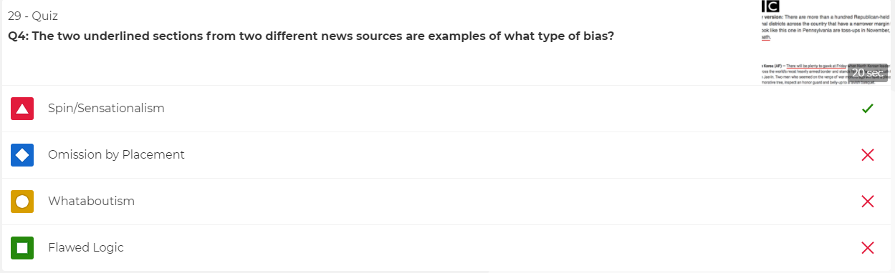
Note: This shows the administrator’s view and not the user’s view.

Figure A2
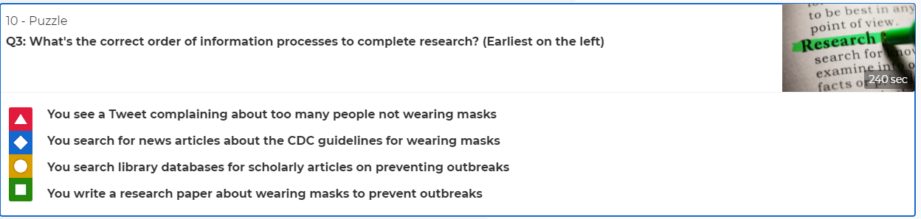
Sample Kahoot Puzzle Question
Note: This shows the administrator’s view and not the user’s view.

Figure A3
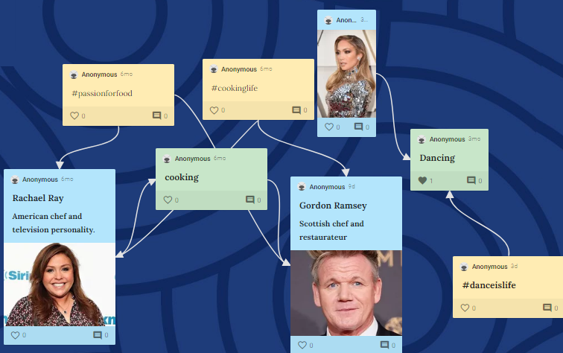
Sample Padlet Collaboration. One student added “cooking” as a topic

Figure A4
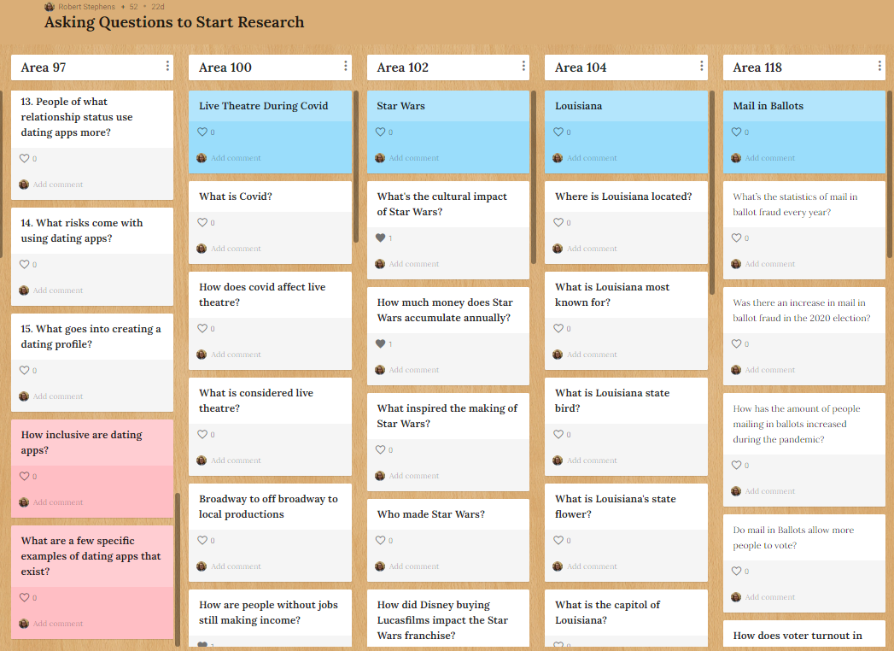
Using Padlet for Inquiry. Topic in blue, student questions in white, peer questions in red.

