**RAD! Creation of a Research and Access Services Department**

*Peter Klubek, University of Louisiana at Lafayette*



**Abstract**

The article presented a case study of a service department and desk reconfiguration through the establishment of a Research and Access Services department at a university library, highlighting the strategic merger of the Reference and Circulation departments to enhance service delivery. This reorganization sought to streamline operations, improve user experience, and optimize resource utilization. By combining these two traditionally separate functions, the new department provided a more cohesive and efficient service model, reducing redundancy and fostering greater collaboration among staff. The article also offered recommendations for other libraries considering similar restructuring. It emphasized the importance of careful planning relying on literature from the ALA, ACRL, and RUSA. The article concludes that such a merger can lead to significant improvements in service efficiency and effectiveness, ultimately enhancing the library role in supporting academic success.

*Keywords*: Research and Access Services, university library reorganization, reference and circulation merger, streamlined service model, library service optimization

**Introduction**

The University of Louisiana at Lafayette achieved R1 status in 2023, thanks to a record-breaking $181 million in research grants and expenditures. As a four-year institution situated in the heart of Louisiana's Acadiana cultural region, this prestigious designation has unlocked a wealth of opportunities across the campus. One tangential result was a transformative reorganization within Edith Garland Dupré Library, integrating its Reference and Circulation Departments into one department called Research and Access Services. This shift in operations was the direct result of several retirements, a new administration seeking to revamp services to more effectively allocate library spaces, and to better meet the needs of researchers at an R1 university. Similar moves are reflective of a growing trend in modern library management with a shift towards enhanced efficiency and patron-centric service delivery. By converging these departments, the library has not only streamlined its operational structure but also created a more fluid and comprehensive support system for students and faculty.

This evolutionary step represented the culmination of insights collected from both academic and public library sectors. By aligning reference and circulation functions, the library has forged a new relationship wherein information retrieval and resource circulation seamlessly intertwine. This resulted in a service model that sought to break down silos while fostering a holistic approach to patron assistance.

**Literature Review**

A shift was identified in how libraries began defining services in the 1990s. Reports from that time indicated that 63% of the libraries surveyed were using the term “access services” (Dawes, Sweetman, & Elm 2005). By 1996, the Association of College and Research Libraries (ACRL) was using the umbrella term "access services" to encompass a range of library interactions. These included circulation, stack maintenance, billing, user counts, reserves, study carrel and study room reservations, microforms, and interlibrary loan. Importantly, these examples were not exhaustive, and the concept of access services varied from one library to another (Dawes, Sweetman, & Elm 2005).

Access services, as a concept, continued to spread across library and information center sectors, and by 2020, the ACRL developed a more structured framework to formally define access services. The committee tasked with this found it initially challenging to create a working definition due to the diversity of services across libraries. However, they observed that access services generally included more back-end duties and service points, with a primary focus on service overall (Warren et al., 2020). While reference services were sometimes included in this definition, this was not always the case.

In the same year, the Reference and User Services Association (RUSA) updated and revised the definition of Reference/Research Services. This working group first acknowledged the established need for information, distinguishing it from additional workshops or programming that libraries might offer. They examined the processes involved in reference/research services and identified key aspects such as information expertise, resource recommendations, service promotion, and the management of service points (American Library Association, 2020). Additionally, the American Library Association (ALA) included the standard competencies required for reference/research work, which had been established in 2017.

The 2017 taskforce on reference/research competencies developed several key points that were built upon the previous set of competencies. Notable new additions included understanding numerical literacy and statistical literacy and knowing the principles of assessment and response to diversity in user needs (ALA, 2017). Overall, these developments reflected the evolving nature of library services and the efforts to provide clear, consistent definitions and standards across the profession. They also provided a foundation upon which to build a new patron service model that encompassed all these concepts in one department (ALA, 2017).

**Methodology**

The ACRL Framework for Access Services, the ALA Definition of Reference Services, and the RUSA Professional Competencies for Reference and User Services Librarians were all used to guide the merger process at Edith Garland Dupré Library. The concept was to form one department with centralized service points that included Circulation, Reference/Research, Reserves, patron count/security, billing, and stacks maintenance.

Each of these services was included in the ACRL framework for Access Services and were therefore integrated into the new department as outlined by the framework. The ALA Definition of Reference Services provided a guide for overlap between the two departments, particularly with the emphasis on service and established service points. This was used to form the new service desk that would handle all these day-to-day transactions. The RUSA Professional Competencies for Reference and User Services Librarians was used to re-establish and re-define the job descriptions of both the former Reference Department staff, and the former Circulation Department staff. The revised employee handbook was also based on these revisions and core competencies.

Social research and methodologies have been described as a means to formulate archetypes (Morgan, 1983). An archetype can be considered essentially a case study because both serve to illustrate typical examples within a larger category. An archetype distills the common characteristics, behaviors, and patterns of a particular group or concept, providing a model that represents the essence of that group or concept. Similarly, a case study provides an in-depth examination of a single instance or a few instances within a broader category, aiming to uncover insights and patterns that can be generalized. In this way, an archetype acts as a conceptual case study, capturing the defining features of its subject through detailed, representative examples.

Case studies were further described as a methodology that do not fit into models more experimentally or survey based. It has been found to be most useful in educational settings and can produce data that could be the subject of more intense investigation (Burns, 2000). This research was presented as a case study to illustrate the pattern, framework, and characteristics that defined the merger of departments at Edith Garland Dupré Library. Further, this real-world example from an educational setting could serve as a model for more in-depth investigation as outlined by Burns.

**Results**

A new department titled Research and Access Services was formed. This department was housed in the former Circulation Department space and included staff from both the Circulation and Reference Departments. Under the newly created organizational chart, personnel were placed under the direction of a single MLIS holding librarian with the title of Head of Research and Access Services. Apart from this librarian, the remaining eight permanent employees were non-MLIS civil service library support staff. Four library specialists reported to a library specialist supervisor, who reported directly to the Head of research and Access Services Librarian. Student workers and stacks maintenance employees reported to a library specialist assistant that also reported directly to the Head of Research and Access Services Librarian. Including the librarian, the department totaled nine permanent employees. The total number of student workers fluctuated from semester to semester. The organizational chat can be viewed in Figure 1.

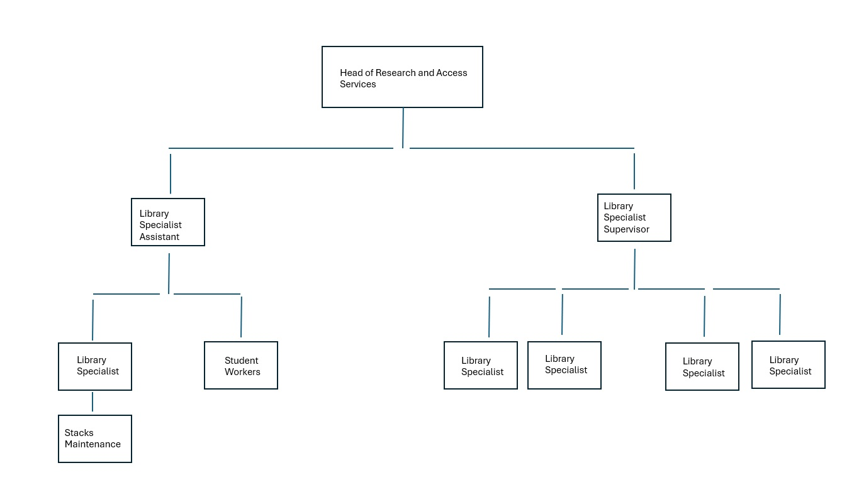

Figure 1. Research and Access Services Organizational Chart

The merger of departments enabled the creation of a centralized service point for library users, greatly enhancing the convenience and efficiency of library services. By utilizing the curved design of the former Circulation Desk, an “Arc of Services” was established. This design strategically organized library activities, with circulation specific services concentrated at one end and reference specific services at the opposite end.

The middle section of the “Arc” represented a comprehensive service area where both circulation and reference transactions could be handled seamlessly. This centralized approach allowed for a more integrated and user-friendly experience that included book check-out and return, item location look-up, research assistance, room checkout, discovery services and more. At the reference end of the counter, staff were responsible for monitoring the reference chat and setting up one-on-one consultations with librarians. This area was designed to support in-depth research assistance and personalized help for complex queries. Conversely, the circulation end of the counter was focused on activities such as handling fines, processing payments, managing the book drop, and organizing the hold shelf.

If a student unfamiliar with library procedures approached the desk looking for reserve items, they could also receive assistance in locating related articles for a bibliography, setting up an interlibrary loan account, and arranging to check out a study room—all from one location and by interacting with a single staff member. This streamlined process eliminated the need for the student to visit multiple locations and speak with different personnel, thereby saving time and reducing confusion. This “Arc of Services” not only improved the user experience but also made the library's operations more efficient by centralizing key services and allowing staff to collaborate more effectively. An illustration is included in Figure 2.

Figure 2. Illustration of the "Arc of Services."

**Discussion**

The merging of library departments did not come without challenges. Although the former Circulation Department occupied a larger area than the former Reference Department, determining how these two departments would share a single physical space presented several issues. Solutions were found in the retirement of two civil service Circulation Department employees that freed up office space for incoming civil service personnel from the Reference Department. Additionally, a weeding project the semester before the merger cleared space previously occupied by VHS, cassette tape, and DVD collections. Consolidating this space and removing some shelving allowed for more efficient use of the area. This example suggests that other academic libraries may consider retirements and employee turnover when deciding to combine departments. Weeding, an essential process for any library, can also offer unexpected benefits, such as freeing up space for new initiatives like departmental mergers.

Managing employee responsibilities also represented a significant change. Previously, the Circulation Department handled opening and closing procedures, while Reference Department staff did not participate in these tasks. Consequently, reference personnel had to adjust their schedules to align with those of the former Circulation Department. Furthermore, circulation employees, who were accustomed to directing research questions to another desk, now found themselves needing to provide answers directly. Training employees and redefining their day-to-day tasks are crucial considerations for other academic libraries contemplating a similar consolidation.

For libraries considering combining departments, conducting a survey of patron satisfaction could also be beneficial. At the time of this writing, the merger had been in effect for only six months and included only one semester. Consequently, no significant data had yet been collected from Dupré Library. Understanding how students, faculty, and other library users perceive these changes can inform future policymaking. While the merger appears logical from an administrative standpoint, it is essential to assess its impact on users to ensure that service quality is maintained and improved. A future study may involve a survey of how this merger affects library users directly.

**Conclusion**

Overall, the merger of the Reference and Circulation Departments at Edith Garland Dupré Library at the University of Louisiana at Lafayette has been successful. Trends in access services, as identified by the ALA, ACRL, and RUSA, have informed and supported the development of a combined service model. The insights and guidelines provided by these professional bodies have been instrumental in shaping our approach. Moreover, the newly established Department of Research and Access Services at Edith Garland Dupré Library could serve as a model for other academic libraries considering similar integrations.

**References**

American Library Association. (2020). *Definitions of reference.*

<http://www.ala.org/rusa/guidelines/definitionsreference>

American Library Association. (2017). Professional competencies for reference and user services librarians. <http://www.ala.org/rusa/resources/guidelines/professional>

Burns, R. B. (2000). *Introduction to research methods*. Sage Publications

Dawes, T. A., Sweetman, K. B., & Elm, C. von. (2005). Report on access services. *Access*

*services*. Assoc. of Research Libraries.

Morgan, G. (1983). *Beyond method: Strategies for social research*. Sage Publications.

Warren, B., Armstrong, D., Boucher, A., Harper, J., Pierard, C., Thoulag, J., & Ketchum, D.

(2020). A framework for access services librarianship: An initiative sponsored by the association of college and research libraries’ access services interest group [Report]. *Association of College and Research Libraries*. <https://alair.ala.org/handle/11213/17206>