Traiteurs: Faith Healers, Folk Medicine, and Medical Traditions

Christopher Bienvenu, Louisiana State University
Abstract
This paper strives to look at various user-centered approaches within information environments as it pertains to colloquial jargon, specifically the use of the words traiteur to describe Cajun faith healers/folk doctors and buaji to describe faith healers of several different faiths in India. Focus groups, multiple constituencies and their differing needs, types of resource, and how this affects libraries and archives specifically in South Louisiana will all be discussed. Also considered will be information-seeking behaviors of two diverse constituencies. This paper will look at a way to circumvent the Library of Congress (LOC) subject headings to allow patrons of libraries and archives to find the information they are searching for in a quick, succinct manner. The usability of the system and the ability of the user to quickly find the information is what is most important in this case. We were successful in adding an LOC subject heading and will also explore how to make sure patrons are able to find the catalog entries so they can spend more time researching the topic by utilizing a different line on the MARC record and creating a LibGuide. This will further help establish the University of Louisiana at Lafayette as the Université des Acadiens. This paper will look at the sources that were located and attempt to synthesize the information in a way that allows the reader a better understanding of not only what exactly a traiteur is, but also why these issues arise and their importance to patrons and library staff alike.

Traiteur is a French word that means healer. Though Cajun French does make use of the feminine traiteuse, the pleural form traiteurs is what is commonly searched for. In South Louisiana, traiteurs are believed to be close to God and who use this relationship along with herbal remedies to cure people. This is done predominately by praying over a person using Catholic-based prayers recited in Cajun French, but there are some variations. In many places around the world, faith healers are important cultural parts of everyday life. However, in some places, it is hard to find any information on these practices. Many of the people who practice these rituals are secretive about their doings, but looking for it in an organizational setting, such as a library, can be an arduous task. Library of Congress Subject Headings do not allow for the use of local language in many cases. When a patron is looking for information on Louisiana faith healers, the traiteurs, they will find very little if anything in the online public access catalog (OPAC). They would need to know that the only accepted subject headings from the Library of Congress are “spiritual healing” and “traditional medicine.”
This research arose from a need. At the University of Louisiana at Lafayette (UL Lafayette), patrons come in several times a year, sometimes more, searching for information on traiteurs, their prayers, their traditions, and their secretiveness. Many patrons assume if they cannot find the information in OPAC, then the information is not there. That is not the case; however, these healers are incredibly mysterious with their work and are reluctant to talk to anyone they consider an outsider. Because of this issue, it is quite difficult for patrons to find the items they are looking for. This research will look into some of these problems both patrons and library workers have finding these items and some possible solutions. These solutions will include alternate ways to add this colloquial jargon into MARC records, the inclusion of LibGuides, and inclusion of these subject headings in archival programs such as ArchivesSpace for archival use. In all, it is about the usability of the system for the patron. In South Louisiana, the use of the term traiteur goes hand in hand with some of the items used in holistic treatment. Gombo filé is a tea made from the leaves of sassafras albidum used for colds and measles. Locals know what gombo filé is but may think of sassafras as a different plant. The same goes for words such as Absinthe (wormwood), chardron (thistle), chou-gras (pokeweed), and mamou (coral tree) among others. It is vital to make this information more easily found. The university is known as the Université des Acadiens, meaning they are the university of the Acadians, specifically the Cajuns, who are the Acadians in Louisiana. (Lançon, 1986, p. 8)
In order to find relevant data, EBSCO, JSTOR, the UL Lafayette, and Louisiana State University OPACs were searched. The search terms traiteur, buaji, folk medicine, traditional medicine, faith healers, faith medicine, and spiritual healers were all searched. Not surprisingly, very few sources were found.
Literature Review
Traiteurs
In Lançon’s (1986) thesis, he notes that traiteurs do not consider themselves as spiritual healers; they consider what they do folk medicine. This is one reason the cataloging of these materials can be difficult. Their skills have been built on centuries of work consisting of a mixture of Catholic faith and Amer-Indian medicine. Throw in knowledge collected from the Spanish, Italian, German, English, Irish, African, and Haitian cultures, you have an adaptation to the values, beliefs, and community of the Cajuns (Lançon, 1986, p. 2). He makes the point that, “folk medicine refers to the beliefs and practices of people regarding matters of health and the body, which are a part of the oral and customary traditions of that people” (p. 16).
A very important question here is what is a traiteur? According to Lançon (1986), “In simple terms, a traiteur is an intermediary of God, who has the ability to treat illness by means of prayers or religious incantations. As such, most traiteurs are deeply religious people, although this is not always the case” (p. 23). As the population began to grow and advances were made in modern healthcare, why did the Cajuns continue then and still continue to visit traiteurs? David points out that though there are advances in modern medicine traiteurs fill an important role. This role is one of a spiritual piece of mind (p. 307). Lançon found an answer from Brandon’s book American Folk Medicine. Brandon (1976) states,
The answer is almost always the same: because there is much that is inconclusive in modern medicine; because hospitals and doctors do not fulfill the needs of the patients; because in a given case the doctor did not cure the illness, especially when it was chronic; and finally, because the healers always demonstrate empathy for their patients, and exude optimism, which doctors are incapable or unwilling to do. (p. 216)
This belief in folk medicine relies on three things, “remedies, magic, and faith healing.” Each can also be distinguished by four characteristics: “disorder type, treatment type, location of treatment, and goal of treatment” (Lançon, 1986, p. 16). Lançon defines remedies as “Natural treatments for natural disorders” (p. 20). Magical treatments are harder to define but consist of “stripping of the illness or disorder from the body” (p. 22). He comes to the conclusion that faith healing
…includes supernatural treatments for natural disorders. For traiteurs, these treatments are always external and are curative, never preventative. The important part of the treatment is that the person being treated believes in the treatment. The traiteur will never ask for payment and must never be thanked, though it is permissible to leave a small donation. This renders the treatment ineffective. The tradition is handed down from one traiteur to someone younger and the opposite gender. (Lançon, 1986, p. 25)
In Davis’ (2000) dissertation, it is stated, “This work centers on the co-existence of the two healing systems, traditional and scientific” (p. vii). This is an important note. These traiteurs do not purport to be the be all end all when it comes to healing. They do still believe in modern medicine; they are simply there as a way to help.
Lançon approached his research in several ways. The majority of his information was gathered by conducting interviews with traiteurs, which is the qualitative approach to research. While he met with each person on several occasions, he also conducted two questionnaires, which is the quantitative approach to research (Lançon, 1986, p. 5-6). The first questionnaire focused on biographical information where he focused on open-ended questions, allowing the person to add as much detail as they wanted. This information he compiled and represented on a map of the state of Louisiana. This information he included as Figure 1 in his thesis and Figure 1 below. The second questionnaire focused on various other topics. This questionnaire was also qualitative in its approach. He asked open-ended questions, allowing the respondents to provide as much information as they wanted. These topics include “the relationship between traiteurs and the Catholic Church to the informant’s recollection of voodoo practices” (Lançon, 1986). He took the information, extrapolated it, and put it in a format others could use without needing to do as he did and interview eleven different traiteurs.
In comparison, David also performed interviews. However, they were done entirely in French and have no structure. David had a list of open-ended questions and performed the interviews as if they were oral histories. They did include a question asking if the traiteur encouraged visitors to seek modern help as well. The result of this was a resounding yes from everyone asked. David used a mixed methods approach which is a more comprehensive approach.
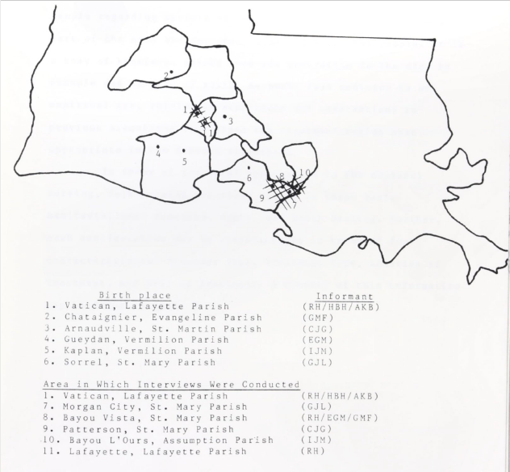
Figure 1: Lançon’s map of interviews. Source: Lançon, 1986, p. 15
One problem with these studies is their age. To begin, there is very little available on this topic. Of the three sources found, these are the two most recent and they are considered quite old by today’s standards. The good thing about it is that very little has changed over the past three hundred years other than modern medicine. The traiteurs recommended seeking out modern medicine and still do today, but will also help in any way they can, especially through prayer. This sometimes can take the form of herbal remedies, which they encourage people to tell their doctors they have taken. This helps the doctors to know if there are any possible medicinal interactions. Despite being 36 and 22 years old respectively, these resources are still as relevant today as the day they were written, if not more.
Lançon’s information seeking scenario appears to focus on healing a patient (Case, 2016, p. 30). It would not surprise the reader to know that Lançon would later become a medical doctor. He does not go into the origins of his research, but he does state that his grandfather was a traiteur (Lançon, 1986). His approach appears to have begun with selective exposure. He was then motivated to acquire more information about this topic that fascinated him. Thus, he crossed the line from intrigued to information. He was entertained enough that he decided to write a thesis on the topic. He wanted to be able to take this information he was learning and put it in a format that could be shared with others. As this was a structured search, he most likely utilized the Kuhlthau Model. As his research progressed, it is clear to see his progression in the model.
As seen in Figure 2, he proceeded through his initiation, selection, exploration, formulation, collection, presentation, and finally assessment. Lançon walks the reader through each of these steps before presenting and assessing the data (Case, 2016, p. 152-153). As he became aware of gaps in his knowledge, Lançon developed a second questionnaire to fill in those gaps. This design would be considered the mixed approach. Lançon utilized this design to gather, analyze, and interpret the data in a way that led to general theories. You can see through his writing that his thoughts moved from vague to focused as his interest increased.
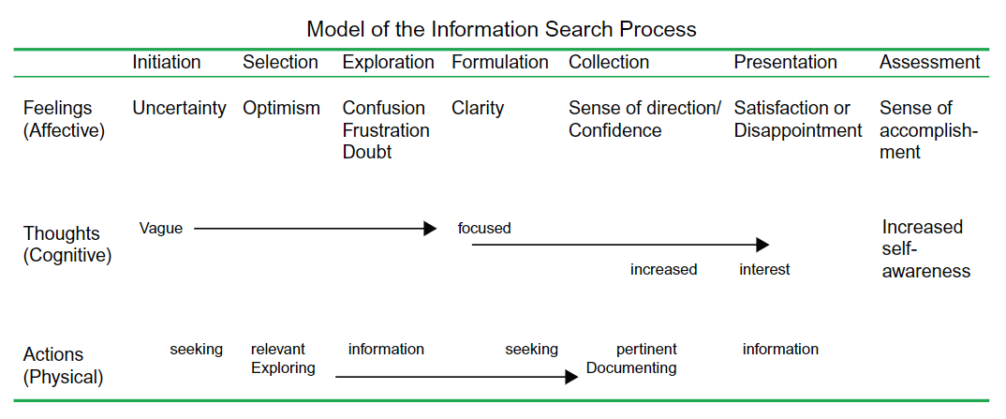
Figure 2: The Kuhlthau model. Source: Case, 2016, p. 153

-Faith Healers Outside of Louisiana
While traiteurs are unique to Cajun culture, the notion of faith healers and folk medicine practitioners is found throughout the world. In Ghana, for example, faith healers work with mental health workers because the faith healers remain popular sources of treatment. Here the treatment of people with mental illness by Christian pastors and traditional healers have come under fire. They have been accused of mistreatment of these individuals who suffer with mental illness. Community Mental Health Officers are now part of an effort to join with these pastors and healers to work together to treat individuals with mental illness (Read, 2019, p. 615). While on an outing to meet with one of the pastors and a traditional healer, Read describes a situation where two men are placed semi-naked in the midday sun, their legs straddling a tree. They were told this is a common occurrence, and “it’s part of your job to engage with these people” (Read, 2019, p. 614-615).
Read (2019) decided to interview and have conversations with health workers to see how they were handling these situations. This was in deference to “…the confrontational approach suggested by rights-based discourse” (p. 629). The morality of the situation was one he was interested in discovering particularly when talking to the mental health workers. He concludes that he is showing how, “mental health workers are seeking to establish the ethical grounds on which to collaborate with healers whose practices contravene global and national rights-based directives” (p. 630). This particular article shows the importance of working with the local faith healers and folk medicine practitioners because they have clout in their communities. It also shows how mental health practitioners went out and developed reciprocal relationships where each side felt they could turn to one another.
In the article by Sharma et al. (2020), the authors used interviews based on a semi-structured questionnaire using both open and closed ended questions. The authors approached these faith healers and their consent was obtained before they began their interviews. These faith healers, locally known as buaji, treat, “…any ill condition by prayer in a temple or masjid, using non-scientific means like giving charms and amulets, using mantras, ash, peacock feather, chilly, lemon and using other such materials where people come because of faith and follow their advices” (Sharma et al., 2020). These healers were followers of Christian, Hindu, and Muslim faiths. (Sharma et al., 2020, p. 4300)
These researchers utilized Wilson’s model of information behavior as seen in Figure 3. They had an intentional acquisition of information and an opportunistic acquisition of information. Regardless of how they obtained the information, the important thing to note here is that they did, in fact, obtain the information they needed. Building upon this information, the reader can see how the researchers followed the path in figure 4 and noticed, stopped, examined, captured, and then returned. They were able to use the information they gathered during this process to plan how they could build relationships with these faith healers in an attempt to help the mentally ill in the regions they served. This approach is the qualitative approach to research. They were able to observe and use their observations “to create a shared conceptual understanding and openness of communication between the researcher and the respondents” (Fisher, 2009, p. 182).
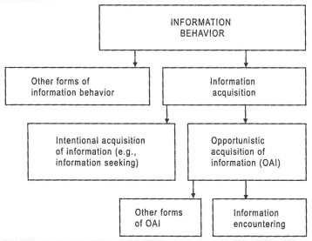
Figure 3. Source: Fisher, 2009, p. 180

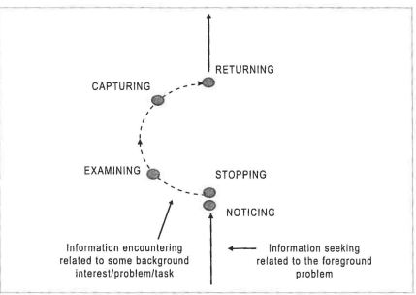
Figure 4. Source: Fisher, 2009, p. 181
In the case of both of these studies, there are faith healers who work with believers and nonbelievers in the community. While it is obvious that there is resistance to their work, as the health care workers build relationships with the faith healers, they begin to work together. It is this collaboration that results in an ideal partnership.
Discussion
In each of the aforementioned articles and studies, we can see that faith healers have a place in society. Why do they not have their own place in LOC Subject Headings? Many people from these areas may not think to search for many of the terms discussed here. Terms such as faith healer, traditional medicine, folk healer, folk medicine, and traditional herbal medicine. They are going to search for what they know. Whether that be traiteur or buaji, people are going to look for the familiar. That familiarity comes in the form of colloquial jargon. These terms are used by hundreds of thousands of people but get no recognition from the Library of Congress. Part of the problem is the fact that there is very little published about them. As more and more is published more subject headings will be used, and maybe that will be a boost the Library of Congress will need to add these more specific terms to their database.
The good news here is that as language evolves, so does the research. As more qualitative and quantitative approaches begin to be published, there will be more data to support the changes libraries want to make. Luckily, software is evolving to help libraries support local jargon. An example of this would be ArchivesSpace. Patrons will begin to expect these to appear in MARC records. Line 690 allows for local subject added entry—topical term. As more librarians utilize line 690, LOC will begin to see the use of these more obscure words entering the system and will be more apt to incorporate them. The important thing to note here is that the librarians are looking at the usability for the patrons. They want the patrons to be able to find the information quickly and successfully. This is what makes this user-centered approach so important.
Findings
Search Results
When searching for more information on traiteurs, EBSCO and JSTOR were used. The term traiteur gave 2,901 results. By filtering these results to only showing the ones in English, there were 794 results. The reason for narrowing the search to only English terms is the fact that traiteur in French means healer and some of the articles that were produced were not applicable to this subject. These results were all about people with the last name Traiteur, with the exception of the above theses. By searching “traiteur and faith healer,” there were only seven results and they were all exactly the same. This is a news article about one traiteur who did an interview in 2019. Only by adding the term Cajun were the results properly narrowed down. There were only five results. The problem here is that students and faculty are the only ones with online access to these databases. Patrons who come in, who are not part of the University system cannot find these journal articles.
In the Ghanian article, there are two constituencies, one being the people being served in the Ghanian communities and the other being the mental health workers and the faith healers/folk medicine practitioners who are working with them (Read, 2019) This article was found by using the search term faith healers in EBSCO. By utilizing this term, the results were limited, but it provided an adequate article for research. Because this is a digital environment, this is available to anyone with access to online databases. This allows the article to have much further reaching impacts than a collection in archives or a book on the shelf in a library.
When it comes to the Indian article, searching EBSCO resulted in 65 results for buaji, but only 49 were in English. Of these, all the results had Buaji, a last name. Adding faith healer to the query provided no results. This further emphasizes the fact that these subject headings matter. They are an important part of these articles, yet it is impossible to find other relevant results when looking for these specific faith healers. The fact that nothing was found when utilizing this local term is quite discouraging and shows the importance of their use.
Outcomes
Since it is very difficult to get new subject headings added to the LOC Subject Heading database, the UL Lafayette library will make use of the 690 tag. This will allow patrons to find information on traiteurs, which was the catalyst for this research. The library also undertook the arduous task of requesting a subject heading addition to the LOC Subject Headings. They wanted to also be sure that each collection with material on or related to traiteurs includes tags to help patrons find the information once they get the program up and running on their website. As a short-term fix, a LibGuide was being created to help patrons when they search the website or come into the archives looking for this information.
When it comes to the two different constituencies, there is a definite difference in the terminology they search for. At UL Lafayette, the first, older constituency tends to spend more time searching and researching, so they know what they want to see when they enter the archives. The second, younger constituency searches a few times, does not see what they want, so they tend to give up faster. By ensuring that this material is more user-centered and user-friendly, the library will not only ensure both constituencies are able to find the materials they seek but may also be in a better position to acquire more relevant and related archives in the future.
Another plan for the archives is to make sure all employees are aware which collections have materials related to traiteurs. This query, while not the most popular, is asked for enough to warrant a special notation. Ensuring the employees, both faculty and staff, are aware of the few collections that contain this information will ensure all patrons are adequately served. The employees are also aware that one of the staff is fluent in French and is available to help with translations if the need should arise, which it does on occasion. The ability to provide translation and transliteration of the prayers is one that has proved quite valuable in the past.
Conclusions
Finally, this is what UL Lafayette is attempting to do with this information. The archives want to extrapolate this information and put it in a format anyone from any constituency can use. Of the patrons that come in looking for this information there are two distinct groups: there is the external population that comes in that tend to be women 50 years of age and up, and then there is the internal population, those who are faculty, staff, and students who are looking for the information for research purposes. These two user groups are looking for two vastly different things. The younger group simply wants to understand what a traiteur is and tries to find the information to learn more about them. The older group wants more detail. They want not only the information the younger group is searching for, but they also are looking for the prayers and the specific traditions, techniques, and treatments used by the traiteurs.
The user-centered approach here is to create a LibGuide that will be accessible on the website and in the archives as well as using line 690 in the MARC record to circumvent the current restrictions. The heads of cataloging and special collections have utilized this opportunity to appeal to the LOC to add the term traiteur as a subject heading. As of December of 2022, this appeal was successful. ArchivesSpace makes this a little easier with the person who inputs the data simply having to select “local sources” instead of Library of Congress Subject Heading. The goal is to make these theses, dissertations, books, and archival collections as searchable as possible. Patrons should be able to find what they are looking for, while also not having to dig excessively through the catalog and website.
The bibliography section included here shows the materials selected to be added to the lib guide and will have the 690 tag added in the collections. These options are all meant to create a more user-centered and user-friendly environment where the patrons can easily find the information they are looking for and easily request the collections from the archives to peruse. The usability of the card catalog and ArchivesSpace is the most important consideration. Without good usability, patrons may assume the library does not have anything to offer and look elsewhere. As UL Lafayette is the university in the heart of Cajun Country, it is vital that this information be readily available and easy to find. Many patrons will assume that if it is not there, they will not be able to find it anywhere. By ensuring patrons can find everything they need, the university will more firmly establish itself as the Université des Acadiens.

References
Brandon, E. (1976). Folk medicine in French Louisiana. In W. D. Hand (Ed.), American Folk Medicine. University of California Press.
Case, D. O., & Given, L. M. (2016). Looking for information: A survey of research on information seeking, needs, and behavior. Emerald.
David, D. A. (2000). Parole, pratique et pouvoir: Le rôle des traiteurs dans la société cadienne. University of Louisiana Lafayette.
Fisher, K. E., Erdelez, S., & McKechnie, L. (2009). Theories of information behavior. Information Today, Inc.
Lançon, J. A. (1986). Des remèdes aux traiteurs : An introduction to folk medicine in French Louisiana.
Read, U. M. (2019). Rights as relationships: Collaborating with faith healers in community mental health in Ghana. Culture, Medicine, and Psychiatry: An International Journal of Cross-Cultural Health Research, 43(4), 613–635. https://doi-org.ezproxyprod.ucs.louisiana.edu/10.1007/s11013-019-09648-3
Sharma, D., Gupta, V., Saxena, K., Shah, U., & Singh, U. (2020). Role of Faith healers: A barrier or a support system to medical care- a cross sectional study. Journal of Family Medicine & Primary Care, 9(8), 4298–4304. https://doi-org.ezproxyprod.ucs.louisiana.edu/10.4103/jfmpc.jfmpc_868_20

