Search Books, Databases, and More: The Swift Rise of Federated Search Boxes and Discovery Services on Academic Library Web Sites
Jennifer Hamilton, University of Louisiana at Lafayette

Abstract
Academic library websites and search tools have changed dramatically over the last decade. Today, federated search boxes, often provided through discovery layer tools and services like the EBSCO Discovery Service, are ubiquitously featured on academic library home pages. Such search boxes mirror the simplicity of a Google search, offering the user a place to begin library research that, by design, includes results from a wide range of resources both within and beyond the library's collection. However, little explanation of what resources are being searched by using these Google-style boxes is available to users. This paper examines the evolution and current state of discovery service use and related library instruction on 30 academic library websites described in a 2010 study by Yang and Wagner. This sample of academic library websites illuminates current search layout and instruction trends and the swift rise of federated search boxes and discovery services from 2010 to 2024. Such a rapid change in the scope of searches available through library websites has created a gap in researcher knowledge and general strategic understanding that creates an exciting and critical challenge for online library instruction and website design.
Keywords: federated search, discovery layer tools, library websites, library instruction, academic libraries
Search Books, Databases, and More: The Swift Rise of Federated Search Boxes and Discovery Services on Academic Library Web Sites
In 2010, Dr. Sharon Q. Yang and Kurt Wagner published an evaluation of the discovery tools in active use by academic libraries. They noted, "Our survey of sites shows that most libraries do not offer a simple keyword search box as a default start page" (2010, p. 694). The situation is quite different a little more than a decade later. Search boxes facilitating research are currently featured on the home page of all 30 academic libraries in their original survey and are a standard and prominently placed library start page element at most academic libraries.
Yang and Wagner were unable to examine any libraries using the EBSCO Discovery Service (EDS), which was still being tested and had yet to be adopted by any academic library extensively enough to facilitate evaluation (2010). EDS has since become a common choice, outpacing competing products. According to Marshall Breeding's annual report on the state of library-related technology, "EBSCO Discovery Service, now installed at more than 16,000 libraries, is the most widely used index-based discovery service" (Breeding, 2023).
Index-based federated search tools like EDS and competitors like Primo and Summon (both ExLibris products) have the capacity to scan ever larger numbers of bibliographic records both in and beyond a library’s collection. For example, according to the 2023 Breeding report, "Primo and Summon, Ex Libris’ discovery services, both rely on Central Discovery Index. The index includes 5.1 billion records, representing a 10% increase from the previous year.” Do most researchers using discovery service search boxes on academic library websites have any idea how wide a net that search is casting?
Awash in a wealth of bibliographic riches, the library literature reflects how libraries now must thoughtfully prioritize default results to favor print books from the collection to improve circulation and prioritize full-text results to reduce the user frustration that can arise if a library’s collection and open access resources are lost in a sea of billions of records that would require interlibrary loan (Bonner & Williams, 2016). As such powerful federated search tools become user favorites, other issues facing libraries include how best to integrate library catalog results into index-based searches and whether a separate catalog search is needed. The 2023 Breeding report noted that 78% of ExLibris customers subscribing to both Primo (an index-based discovery tool) and Alma (library catalog search software) are choosing a “version of Primo fully unified with Alma, with 180 libraries making this transition last year” (Breeding, 2023).
The research for this paper began with a literature search for best practices of academic libraries in website design and library instruction related to the federated search boxes now so prominently featured. The initial primary research question was whether other academic libraries provided online library instruction at the point of user need, next to or integrated within the search box. If so, were there established best practices or related literature? If not, how extensive was the explanation on current academic library websites of what type of resources were being searched if a user initiated a search with the box so prominently featured by the library? How many clicks would it take, or would it require a full search of the library website to locate a guide to the different types of searches available, with advice for users on strategic use of each?
Literature Review
As discovery services have been more widely adopted in academic libraries to facilitate user access to collections and the broader, indexed world of scholarly publishing beyond library holdings, librarians have reflected on and studied this change. During the fourteen years since Yang and Wagner’s 2010 survey, the potential utility, most strategic deployment, effect on search, implications for outreach and library instruction, and issues related to discovery services and federated search have all been examined in library literature.
In "A Small Academic Library and the Power of EBSCO Discovery Service" authors Bonner and Williams described the collaboration between the Whitaker Library of Chowan University in North Carolina and EBSCO to significantly improve the results provided by the EDS search box on the library's home page (2016). Adjustments that improved the utility of search results for Whitaker students included changes in the administrative settings of the discovery service to prioritize Whitaker's collection of print books and to JSTOR holdings with branded links to full-text articles. Calvert's 2016 study, "Maximizing Academic Library Collections: Measuring Changes in Use Patterns Owing to EBSCO Discovery Service," demonstrated the negative effect that index-based discovery systems can have on print collection circulation and suggested that these effects can be mitigated by adjustments such as the one Whitaker Library chose to make, prioritizing print holdings in discovery service results.
EBSCO's release of the EDS platform in February 2013 offered a broader federated search than available in the past, expanding to "include printed books, e-books, audio-visuals, open access articles and government documents in one list" (Chew et al., 2017, p.145). At Wawasan Open University, librarians worked with IT staff and faculty to expand EDS federated search access by providing search bars both on the library's home page and through a widget embedded in Moodle pages for select courses (Chew et al., 2017). Integrating a library research widget in the pages students use to track course progress, access learning materials, and submit assignments significantly enhances student access to library resources. Where learning management systems (LMS) like Moodle are a primary point of student contact with the university, the LMS is a strategic place to embed direct access to library resources (Chew et al., 2017, p.138).
North Carolina State University (NCSU) Libraries has employed the ProQuest Summon web-scale discovery service since 2009 (Ciccone & Vickery, 2015). In 2015, Karen Ciccone and John Vicery published a study comparing the results of a sample of 183 user searches in Summon, EDS, and Google Scholar. At time of study, Summon results were limited to book chapters and scholarly articles, and sample searches for both known items and topics were pulled from library search logs to better assess relevancy in actual use cases. (Ciccone & Vickery, 2015)
Koury and Brammer (2017) summarized how librarians at Idaho State University Libraries worked with EBSCO to customize their EDS deployment to improve search result relevancy. Of note was ISU's use of Crazy Egg heat map software to track whether or not library users clicked a link adjacent to the EDS search box featured on the library's home page to learn more via a LibGuide explaining the resources being searched. "In the six-month period after Crazy Egg implementation, only sixteen people clicked on the OneSearch LibGuide link, while the OneSearch tab was heavily used" (Koury & Brammer, 2017, p.84). As a result of this user study, the library decided to simplify the description of the federated search box to, "Get started with a quick search of the catalog and multiple databases” and to remove the LibGuide link (Koury & Brammer, 2017, p.84).
Meirose and Lian (2019) of the Skelton Medical Libraries and the Mercer University School of Medicine described their 2015 user testing of ten first-year medical students attempting to use EDS to retrieve relevant full-text, eBook, peer-reviewed, and print items. In partnership with EBSCO, this study provided participant incentives and funded use of Usertesting.com. Most study participants were able to find relevant results, though some struggled with the use of limiters to find specific types of resources, particularly print books. Meirose and Lian concluded that the wording of the Catalog Only and Books limiters created confusion for students, and suggested alternate wording might help users better navigate the interface (Meirose & Lian, 2019).
Pulikowski and Mataysek (2021) compared the relevancy of search results on library and information science related topics via Google, Google Scholar, EDS, and the Library and Information Science Abstracts (LISA) database. In this study, the authors concluded that Google searches yielded the best results in each category of measurement, followed closely by Google Scholar and trailed by EDS and LISA results.
Survey of Academic Library Sites
Research Questions
As mentioned above, this paper was prompted by a primary research question regarding the extent to which academic libraries currently provide instruction for users near or within the search boxes featured on library home pages. Yang and Wagner’s survey presented an opportunity to answer this question with an updated look at the 30 academic libraries featured in their 2010 study (see Figure 1). This sample included a thoughtful mix of academic libraries in both public and private universities of varying sizes, locations, and funding levels. Yang and Wagner originally selected that particular set of libraries to represent users of the most common proprietary and open-sourced index-based discovery services available at the time. It seemed promising to investigate an established sample set of libraries that had potentially been working with discovery service integration for over a decade. How many of those libraries would still be using the same solutions? How prominently would each library feature a discovery layer search 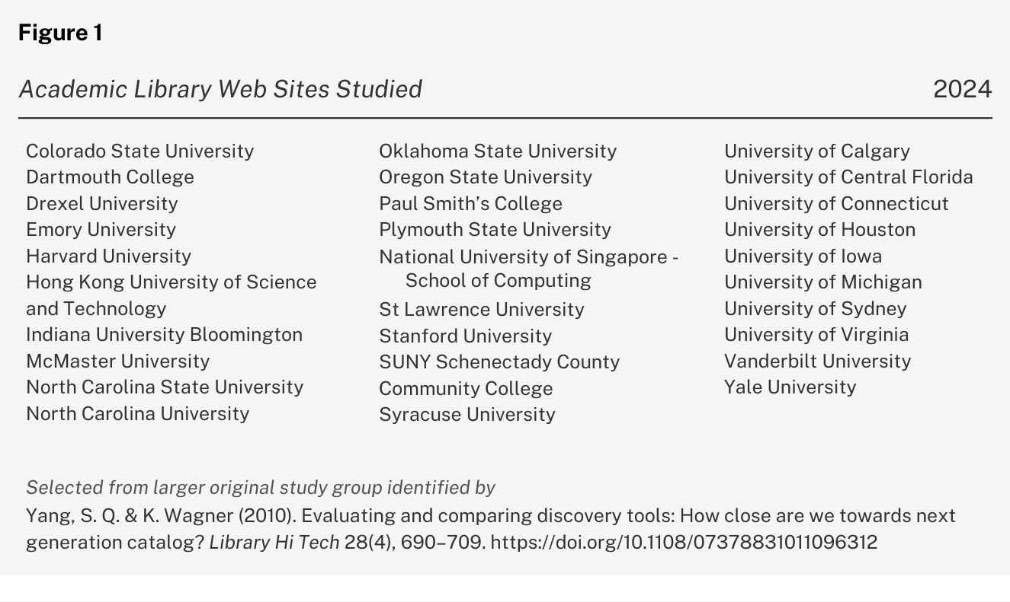box on the home page of their website? Would any of the previously surveyed libraries have developed explanations of the scope of the discovery layer searched that were available to library users within or near the point of search? What best practices in related library instruction might these early adopters have developed in the intervening 14 years?
It is worth noting that the author of this paper was asking these questions in her role as Head of Instruction at the Edith Garland Dupré Library of the University of Louisiana at Lafayette. The Dupré Library features an EBSCO Discovery Service search box on its website (http://library.louisiana.edu) but had not at the time this paper was written yet developed point of access library instruction informing users about the mechanics and breadth of sources included in an EDS search. The best practices noted in the survey described here will help the Dupré instruction team develop and place such resources. They are offered to fellow instruction librarians and library website designers interested in providing users with more support in navigating an increasingly complicated academic search landscape largely invisible to the average user.
Survey Design
For the updated survey, notes were taken in a Microsoft Excel spreadsheet comparing data published in Yang and Wagner’s 2010 paper with what could be observed on the websites of the same academic libraries in 2024. New data collected included current library web address, choice of discovery layer solution, what words were used to describe the search, whether a description of what was searched was included in or near the search box, and whether related library instruction was provided from the first page of search results or elsewhere on the library site. Because the survey was intended to see what resources were discoverable by the average user, if an answer to any of the questions was unclear, it was coded as unknown. As the primary objective of the study related to approaches to online library instruction related to federated search rather than choice of vendor or software, it was not deemed necessary to follow up to identify federated search solutions coded as unknown.
Survey Results
Simplification of Academic Library Website Addresses
One change that became quickly apparent in the course of this study was that of the 30 academic library websites assessed by Yang and Wagner in 2010, seventeen (57%) have home page addresses that have changed since 2010. Some of the changes between current library web addresses and those listed in the original study reflect changes in vendor. In other cases, addresses changed because it is no longer necessary to go to a specific subpage of the overall library web site to access discovery services (for example, http://discovery.library.colostate.edu can now be accessed at http://library.colostate.edu). Most of the updated library web addresses now begin with “library” or “lib.” Examples of such changes made between 2010 and 2024 include
- http://library.orogonstate.edu (formerly http://osulibrary.oregonstate.edu),
- https://library.stlawu.edu/ (formerly http://www.stlawu.edu/library)
- http://lib.umich.edu (formerly http://mirlyn.lib.umich.edu)
The reasons and extent of such web address changes among academic libraries is beyond the scope of this paper but might make an interesting research question.
Prominence of Search Bar on Home Page
Yang and Wagner noted that placing a single federated search bar on the library home page was a new trend in 2010. Just shy of a decade and half later, a library home page that didn’t feature a prominent search bar would be surprising. Yet in this review of academic library sites, there was still visible variety in layout and the degree of prominence of the search bar. Most discovery service and/or catalog and other search boxes on the 30 sites surveyed were large and near the top of the academic library web site, beneath an upper border containing library branding and navigational menus. The search box example shown in Figure 2 from the home page of the Edmon Low Library at Oklahoma State University is set against a rotating series of inviting hero images featuring both interior and exterior shots that include at least one student using or entering the library. Rarely, a small search widget was observed in the upper border of the library’s main page. Commonly, federated search boxes are found set against large inviting photos taken within the library. Figure 3 highlights a striking layout on the Yale Library home page (http://library.yale.edu) in which the search box is featured at the top of the page with the welcoming question, “What can we help you find?” while a picture montage below invites the user to explore physical as well as digital library services.
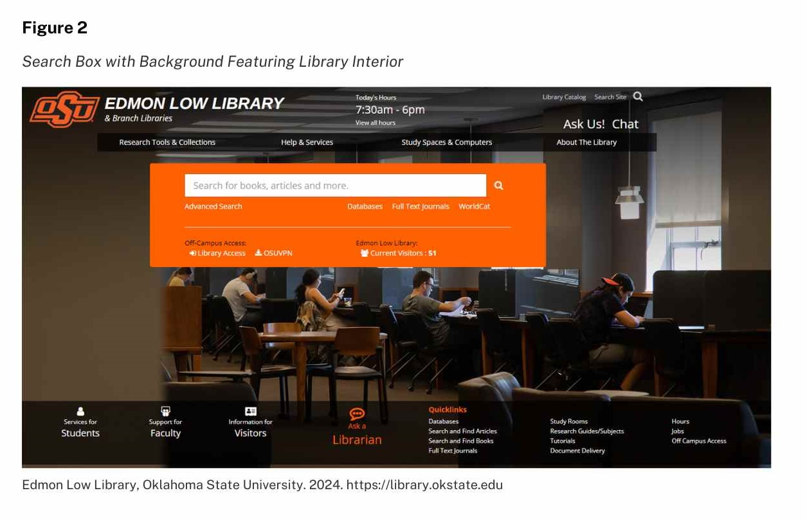
Need for Transparency Regarding What is Being Searched
As noted above, there has been a rapid and extensive evolution of the availability and placement of federated search bars. Academic libraries, whether using proprietary or open source software, can configure discovery tools to search an extensive range of sources from one simple, Google-like search box. Are library users aware of what they are searching when they use such discovery tools? Do researchers using the federated search featured so prominently on library home pages understand what other search options are available? Do users have any awareness of the specialized filters and other features available in databases designed for specific disciplines and source types that are lost in broadly federated discovery layer search results?
Yang and Wagner heralded "A single point of entry for all library resources: Federated search is the holy grail of discovery layers" (2010, p. 698). Federated search is remarkably useful, but it also has limits and in many research cases may be best paired with other resources. EDS, for example, can search most but not all databases provided by many academic libraries, and won't search them as effectively as they can be searched one at a time. Most notably, when all resources are combined, discipline-specific facets available in specialized databases are often lost. If researchers are to make informed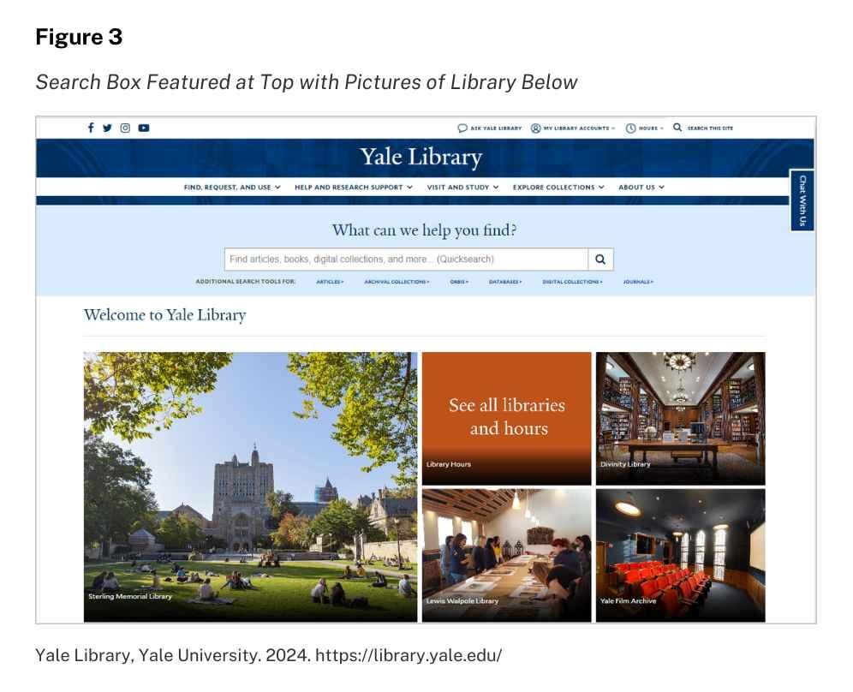decisions about which search tool(s) will best serve their information needs, libraries must do more to provide point-of-use instruction and links to more information that can help them understand the strengths and limitations of each option.
Instruction Integrated Within or Near Search Box on Home Page
Examination in 2024 of the 30 academic library websites described Yang and Wagner’s 2010 study revealed a range of approaches to explaining discovery service search tools to users. Effectively integrating related library instruction within and around the home page search bar is a significant user interface and design challenge. McMaster University, Colorado State University, and Stanford University libraries each provide useful examples of the different strategies currently being employed to explain discovery service search tools to users at point of use and in linked library information guides. 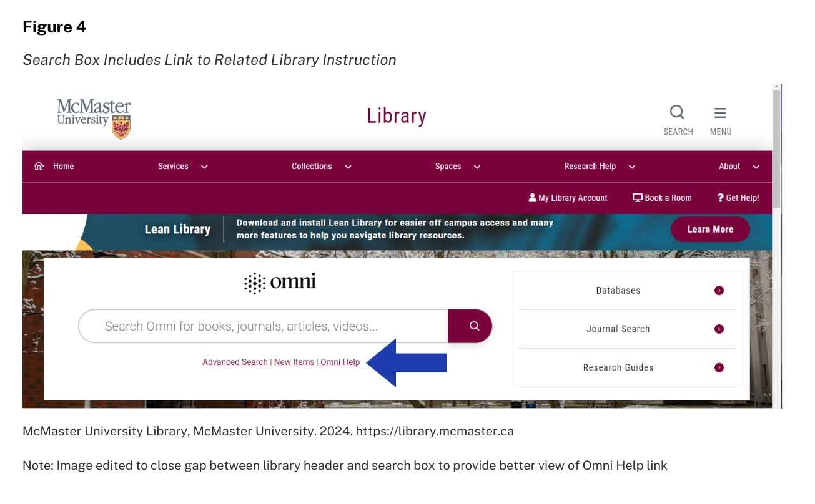
McMaster University Library offers users a prominently placed Omni federated search box on the library homepage (http://library.mcmaster.ca). Figure 4 illustrates how the McMaster Library search box includes within it a link to “Omni Help.” The Omni Help link takes users to a LibGuide (http://libguides.mcmaster.ca/omni), the header of which is shown in Figure 5, explaining in simple terms what the scope of an Omni search includes, as well as providing access to a wealth of additional information to guide researchers. McMaster’s model of providing online library instruction at point of use represents a potential best practice for library instructors and website designers striving to balance the provision of critical explanation and context without cluttering the simple search bar interface.
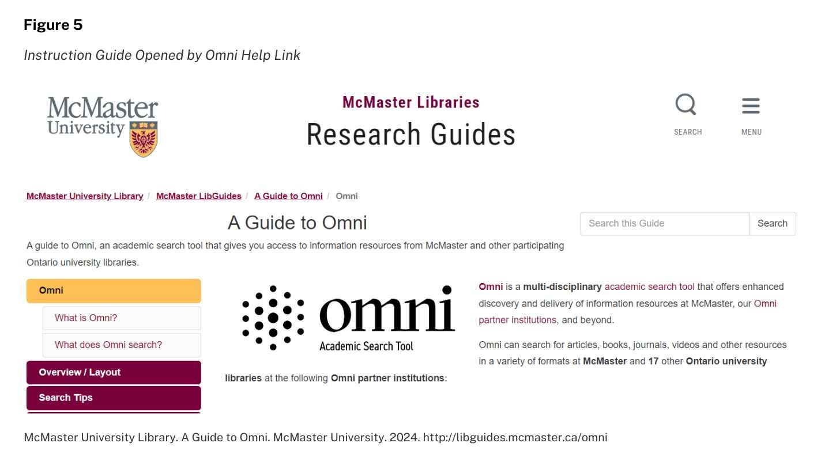

Customization options vary for different academic libraries depending on chosen discovery layer vendor and underlying code design. If user help linked directly from within a federated search box is not an option for an academic library, guidance and related library instruction can also be provided with links beneath, above, or otherwise adjacent. Using SearchWorks: Searching the Library Catalog and Articles+ by Stanford Libraries (https://guides.library.stanford.edu/c.php?g=1081009&p=7878023) is an excellent example of library instruction provided by a link adjacent to the search box that directs users to a description of the scope of the search with additional user guidance and research tips.
Vendor-Supplied Information Pages are a Useful Resource
If a library has not yet added extensive point of use library instruction on the home page regarding the nature of a federated, index-based discovery search, there is often helpful information available from built-in instruction provided in most proprietary search products on the first results page. An example of good use of available customization features offered by a discovery service vendor can be found at Colorado State University. Once a search is initiated, "Almost Everything" is the default search option on the Colorado State University Libraries home page (https://lib.colostate.edu), and that description alone is instructive and inviting. Some example material types are listed in the search bar when this option is selected, where a prompt reads, "Explore PRIMO for articles, books, and more."
If a user enters a search term using the "Almost Everything" option, results are provided in a PrimoSearch window, as shown in Figure 6. This window includes a search bar at the top, where the PrimoSearch Logo to the left of the search bar is clickable. On click, the user is taken to a page that offers a simple explanation of what is searched (https://colostate.primo.exlibrisgroup.com). Links are also provided to a list of specialized databases, and to ways to access reference services or provide feedback. Chat remains visible via a bright orange tab on the right. During testing, all places on the Colorado State Universities website where the PrimoSearch logo appeared, it was clickable and led to the same basic description of PrimoSearch and links to facilitate access to library services and reference help
For libraries employing the EBSCO Discovery System, instruction for users regarding search scope and strategies used to be easily found through a help icon in the upper left corner of any search result screen. The new EDS interface currently being rolled out to all subscribing libraries does not provide by default any quick link to EBSCO-designed help pages related to 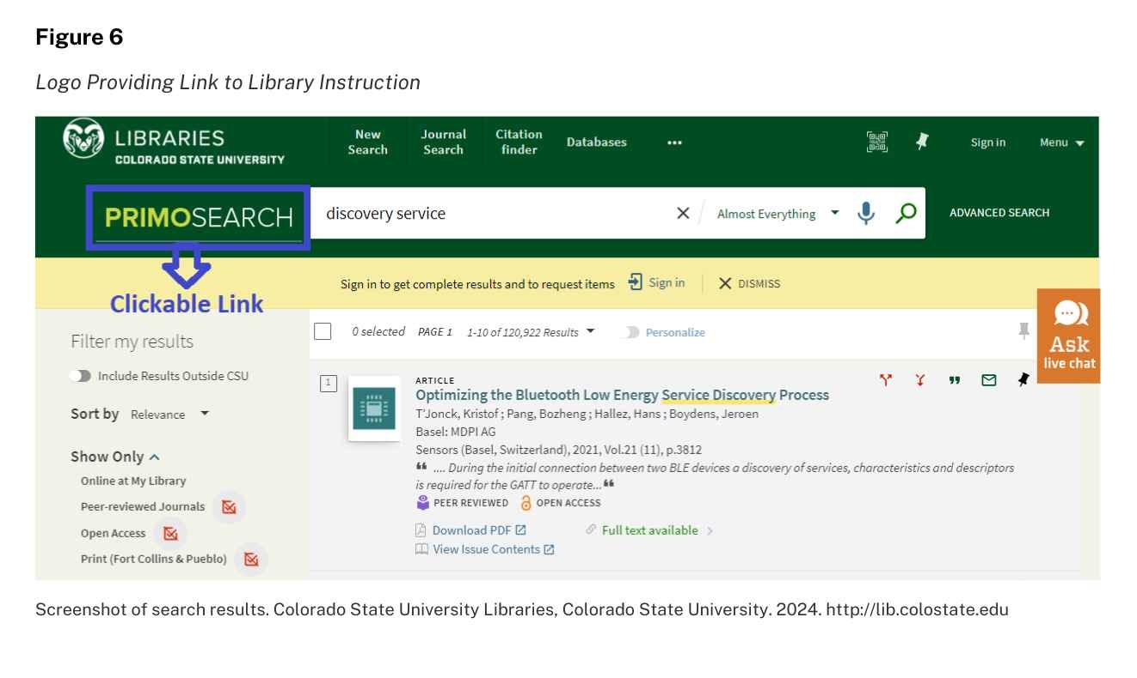EDS. That might be a customization worth discussing with a library’s EBSCO representative, and could be additional incentive for EDS subscribing libraries to develop their own related library instruction resources such as the guides from McMaster’s and Stanford libraries mentioned above. These guides can be featured from within the new EBSCO interface as can any related resource guides offered by the subscribing library. As also mentioned above, library guides on discovery layer searching can also be offered via link within or just below EDS search box featured on any library’s home page.
Consistent Feature Priorities and Notable Shifts for Discovery Services
Yang and Wagner’s 2010 evaluation of discovery tools included a list of features identified as priorities by libraries and industry experts, compiling them in a handy “Discovery tool evaluation check-list" [sic] (p. 694-695). Some of the key features listed reflect search challenges and user interface issues that remain just as relevant today:
- Libraries continue to seek a means to fully federate search, reducing the number of different places users must identify and search separately. Library collections still contain material that users must or can best access by directly searching additional catalogs, databases, digital collections and archives.
- Interface design remains a priority. Libraries and discovery tools continue to use Google, Netflix, and Amazon as benchmarks and models for ease of use, identified by Yang and Wagner as popular websites that set user expectations (2010).
- Relevance ranking remains a challenge for discovery systems and may be perceived differently depending on library and search context.
Some user needs, use patterns, and library priorities have notably changed since 2010. For example, there is no longer as much interest in the option for users to add ratings, comments, and tags when searching library collections, or post search results to social media. Other items Yang and Wagner identified as priority features have become ubiquitous, including persistent links, search suggestions, the option to see more items like a selected resource, and the ability to set up an RSS feed-like automated email alert if new items that match the users search criteria are added to the collection.
Conclusion
The current prominence of discovery service search boxes on library home pages is a relatively recent development. As a practice, placing a simple search box that provides relevant results for users from the widest possible range of resources makes sense. The single search box home page design strategy is evocative of Google search or the search boxes of information sources including YouTube, TikTok, etc., that may be more familiar to users than library search tools. It is worth noting, however, that because discovery services are a relatively new library and research tool, it is unlikely that most users understand what happens when the search button is pressed -- a potential knowledge gap worth further study.
Libraries have begun, as described above, to provide explanations of what federated search and discovery services are and how their results and filter options compare to those available when searching databases one at a time. Understanding the differences between single database search and federated search results empowers users to develop efficient and task-appropriate research strategies. Future implications for library instruction and library web site design include more information provided to users about federated searches and discovery services. Attention could also be productively invested in improving the accessibility of such critical information. Can the user access, at point of discovery service search, a description of what will be included in the search? Future study of the number of clicks it takes for users to access such information and related library instruction could help inform best practice in library web site design.
References
Bonner, S. & Williams G. (2016). A small academic library and the power of EBSCO Discovery Service. Serials Review 42(3), 187–191. https://dx.doi.org/10.1080/00987913.2016.1205428
Breeding, M. (2023). 2023 library systems report. American Libraries Magazine. https://americanlibrariesmagazine.org/2023/05/01/2023-library-systems-report
Calvert, K. (2015). Maximizing academic library collections: Measuring changes in use patterns owing to EBSCO Discovery Service. College & Research Libraries 76(1), 81–99. https://doi.org/10.5860/crl.76.1.81
Chew, B.L., Rahim, M.A, & Vighnarajah. (2017). Integration of EBSCO Discovery Service widget into the learning spaces of LMS: A case study of Wawasan Open University. Asian Association of Open Universities Journal 12(2), 137–153. https://doi.org/10.1108/AAOUJ-01-2017-0013
Ciccone, K. & Vickery, J. (2015). Summon, EBSCO Discovery Service, and Google Scholar: A comparison of search performance using user queries. Evidence Based Library and Information Practice 10(1), 34–49. https://doi.org/10.18438/B86G6Q
Koury, R. & Brammer, C. (2017). Managing content in EBSCO Discovery Service: Action guide for surviving and thriving. The Serials Librarian 72(1-4), 83–86. http://dx.doi.org/10.1080/0361526X.2017.1309828
Meirose, J. & Lian, B. (2019). User testing: Gathering data from first-year medical students as they interact with the EBSCO Discovery Service (EDS). Journal of Electronic Resources in Medical Libraries 16 (1), 1–7. https://doi.org/10.1080/15424065.2019.1590171
Pulikowski, A. & Matysek, A. (2021). Searching for LIS scholarly publications: A comparison of search results from Google, Google Scholar, EDS, and LISA. Journal of Academic Librarianship 47(5), 102417. https://doi.org/10.1016/j.acalib.2021.102417
Rose-Wiles, L.M. & Hofmann, M.A. (2013). Still desperately seeking citations: Undergraduate research in the age of web-scale discovery. Journal of Library Administration. 53(2-3), 147–166. https://doi.org/10.1080/01930826.2013.853493
Oh, K.E., & Colón-Aguirre, M. (2019). A comparative study of perceptions and use of Google Scholar and academic library discovery systems. College & Research Libraries, 80(6), 876–891. https://doi.org/10.5860/crl.80.6.876
Yang, S. Q. & Wagner, K. (2010). Evaluating and comparing discovery tools: How close are we towards next generation catalog? Library Hi Tech 28(4), 690–709. https://doi.org/10.1108/07 ó 378831011096312

