Navigating Change: A Case Study of Formative Evaluations
at Delgado Library
Caitlin Cooper, Shanna Clevenger, and Courtney R. Stortz, Delgado Community College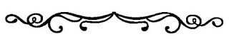
Abstract
This article analyzes and describes the experience of Delgado Community College librarians with using a variety of formative assessments to appraise the effectiveness of the bibliographic instruction modules presented by the librarians. The article covers the trajectory of using these evaluation tools, from the directive to start using them, through the segue to incorporating online versions of the assessments during COVID, to utilizing QR codes. The introductory section summarizes this history and breaks down the total assessments completed by time period. The analysis section includes a discussion of four case studies to illustrate Delgado Library’s formative assessment journey and what lessons have been learned from using these tools, through online versions and QR codes. The section on QR codes discusses how librarians have broadened the scope of formative assessment utilization to include instructors' opinions about the instructional modules and the feelings of general patrons about library services. The conclusion summarizes what has been learned about using formative assessments.
Keywords: formative assessment, instructional practices, student performance, information literacy, critical thinking, student engagement & reflection

Formative evaluations are effective tools for enhancing student learning and improving instructional practices. A formative assessment is a deliberate process in which instructors gather evidence of student learning to adjust their teaching methods. This approach helps educators refine their instructional strategies based on insights collected about student performance (Orblych, 2013). In 2014, the Delgado Library implemented formative assessments in its one-shot library instruction sessions. According to Brossard, a one-shot library instruction session is defined as a meeting designed to introduce students to the library and its resources (Brossard, 2018). With the introduction of Zoom and the challenges posed by COVID-19, librarians have adapted their use of these evaluations by incorporating online formats and QR codes. Formative evaluations are vital for improving student understanding and fine-tuning teaching methods. Delgado Library's strategic implementation of formative assessments, which included adapting from traditional paper-based methods to online surveys and QR codes, has provided valuable insights for improving library instruction sessions and addressing the challenges of low student engagement and participation.
Before we proceed with the assessments, let's provide some background information. The library has collected statistics through an online class climate survey since 2010. Class Climate is a course evaluation feedback system that the college acquired for instructor feedback. Surveys have been completed in this system from 2010 to the present. From 2010-2014, there were no standard formative assessments for library sessions; students only completed a simple yes-no survey at the end of class. A breakdown of the statistics is as follows:
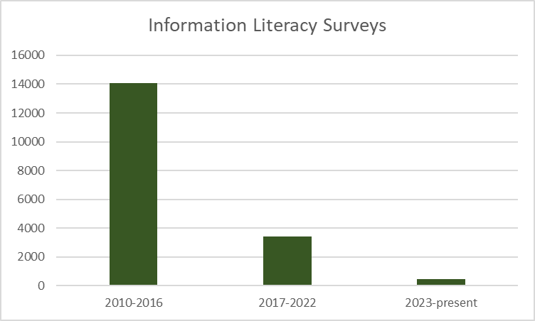
- From 2010 to 2016, 14,055 surveys were completed.
- From 2017 to 2022, 3,422 surveys were completed,
- From 2023 to the present, 477 have been completed.
The decline in the number of surveys is due to the COVID pandemic and the increased frequency of formative assessments, which we now utilize more than class climate surveys.
We used formative evaluations after the Dean of the Library established a task force that included all teaching librarians. The Bibliographic Instruction Task Force reviewed the current instructional practices, analyzed data from student evaluations, and implemented new strategies and learning activities to enhance student learning and success. The task force created a Master Syllabus for our one-time information literacy sessions to ensure alignment with the library's mission and the LCTCS Annual Evaluation portfolio for faculty. Our sessions do not grant academic credit but the Dean suggested that we adhere to the Policy and Procedures Memorandum of Delgado Community College. This document outlines the required format for all credit courses and is part of the College’s Operational Guidelines. It is applied to all instructional sessions, regardless of their teaching method or delivery (see Appendix). The library’s syllabus was based on the master syllabus template provided in the policy, as well as a previously approved syllabus for English 101 (English Composition). Once we determined course descriptions, goals, and student learning outcomes, we shifted our focus to assessment.
The goal was to collect feedback to enhance instruction and collaboration with faculty to improve student outcomes. To facilitate this effort, the task force reviewed Snapshots of Reality: A Practical Guide to Formative Assessments in Library Instruction (Brossard, 2018). Using this book as a reference, we piloted various evaluation methods, including 321 Charts, anticipation guides, and exit slips. By 2015, we successfully incorporated formative assessments into our instruction sessions. Our Systems Administrator created the Formative Evaluation LibGuide, which contains accessible templates for all librarians.
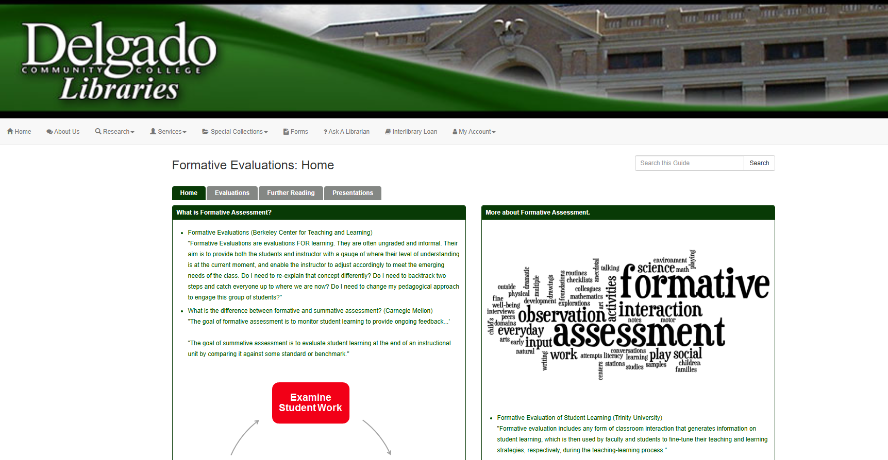
https://dcc.libguides.com/c.php?g=717084&p=10676606
Delgado librarians led a workshop titled “Formative Evaluations and How to Use Them” at the 2016 LOUIS Users Conference. The workshop explained how we implemented formative assessments in our library sessions and discussed the benefits and challenges of using paper evaluations. We also discussed how using tools like the KWL Chart, Tweets, Emoji Tickets, and Wish Lists has improved our assessment strategies. In 2017, librarians presented findings at the annual LCTCS conference, titled "How Do You Know It Tastes Good: Using Assessment for Student Engagement & Reflection. "While some students found the hands-on library instruction beneficial, with one noting, “The library instruction class was perfect for me, especially with the hands-on. That should be mandatory,”—the overall feedback suggested that the sessions did not fully shift student research habits. A key finding was the continued preference for widely used search engines such as Google, as evidenced by one student's comment: “I did not stop using Google, but I do know how to use the databases now.” Furthermore, a significant number of students (67%) reported not seeking assistance after the instruction session, suggesting a gap between the initial instruction and students' sustained engagement with library resources.
Analysis
Case Study: 1
The KWL chart is an assessment that comprises three components that can be used before and after a lesson. The assessments are broken into: K (What you know about the topic), W (What you would like to know about the topic), and L (What you learned from the lesson about the topic).

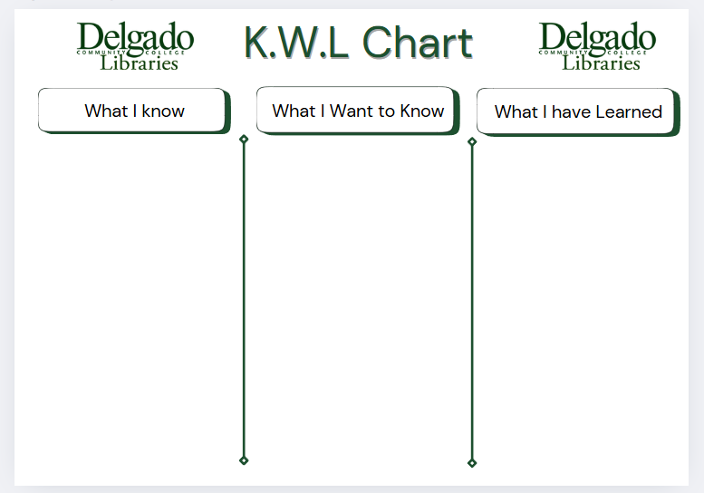
Figure 1: Adapted from Vandevall
At the start of the session, the librarian will describe the assessment and request that students complete the K and W sections. These show their prior knowledge regarding the library, research, and how to use its resources. The KWL chart allows students to use critical thinking and connect their topic with the research process. At the end of the session, the librarian will ask students to complete the L section. This part of the evaluation allows students to review research strategies, database searches, and other skills learned. Data was used from the forms to see how well the students were able to retain the material from the lesson, and if there was any new information gained. This helps librarians learn what worked and what they can improve using students' feedback.
Case Study: 2
The Today's Lesson Tweet Evaluation prompts students to compose a tweet using three questions: "What did you learn today?", "What did you find tricky?", and "What can we do next time?"

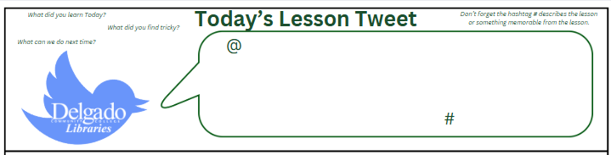
Figure 2: Adapted from Hartley
As a case study, we will explore eight responses, an 80% response rate, from a College and Career Success Skills (CCSS) class of ten students. This class received an overview of library information, services, resources, and specific guidance on creating resumes. The responses indicated that students appreciated learning to access the library’s website and resources. One response included the hashtag “#veryhelpful,” while the others mentioned accessing the library’s website, databases, books, or resume resources. One student expressed a desire for more time spent on the resume portion of the presentation, which was noted as helpful feedback. These responses are typical of evaluations provided in paper format.
The evaluation provided direct feedback for individual classes during sessions, helping students recognize their strengths and weaknesses. However, implementing these assessments during one-time sessions has proven to be challenging, particularly due to class sizes. Many responses were limited to yes/no options or left blank, and some students left without completing the forms. Consequently, these surveys did not yield the information needed.
Case Study 3
In response to the data, the task force created an assessment for both instructors and students to evaluate the information presented and the quality of the instruction. The goal was to determine whether library instruction had a positive impact on student's academic performance and to identify if librarians needed to adjust their teaching methods. We developed a six-question reflection assessment for instructors and students. This was the first time we administered a written assessment to instructors, which could be given either after a one-time instruction session or at the end of the semester.
The instructor's reflection assessment focused on whether a one-hour session was sufficient and if the librarian covered the resources adequately in that time frame. Questions also focused on the quality of the student's work and what improvements could be made in future sessions. We received positive feedback indicating that the library institution sessions enhanced student knowledge and research skills. However, the number of responses was low. The students’ questions examined their expectations concerning what was taught and gathered their suggestions for improving the session. An additional question was included to allow students to voice any concerns. Analyzing the data from the instructors’ assessments with that from the students aided our understanding of student learning outcomes. Thus, it helped identify areas where instructional strategies can be improved.

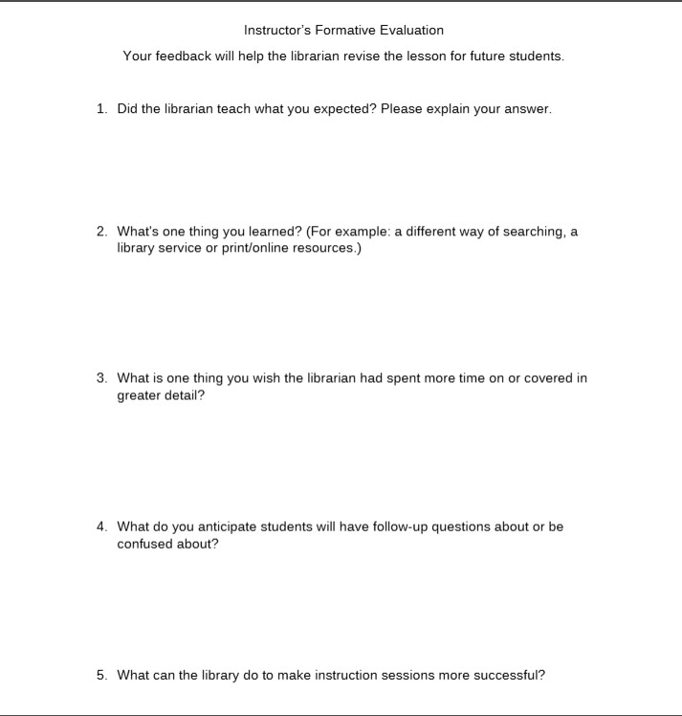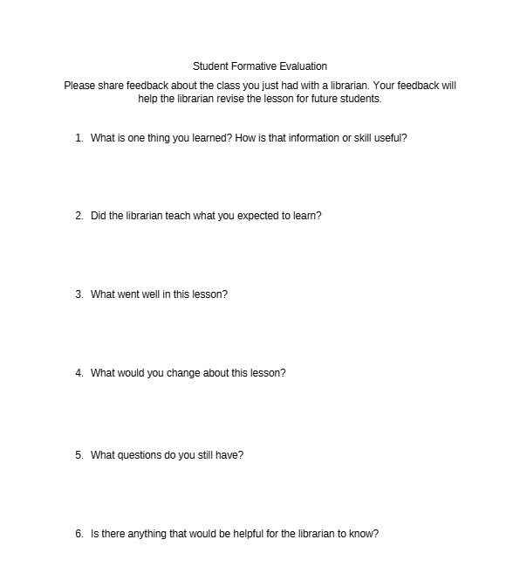
Figure 3: Adapted from https://www.saintt.com/
A pilot of the instructor’s evaluation was launched in 2023 to gather feedback from instructors as well as students. The Instructor Reflection Evaluation consisted of five questions, while the student had six. The Veterinary Technician Assistant instructor stated that library instruction was informative and motivated students to use library resources. Students were also more likely to ask for additional help after the session. Suggestions for improvement were:
- Include information about citing sources and plagiarism.
- Organize walking tours of the library.
- Give students time to work on their assignments.
86% of the Veterinary Technician students submitted their reflection papers. However, a significant number of students left questions blank, accounting for 28.5% of submissions. Students stated they would like a repeat of the library instruction class, indicating that a one-shot session is not beneficial to student success. Thus, the information should be repeated or broken into several sessions. Students stated they would like a more hands-on experience with the materials and facilities.
Transitioning to Online
In 2020, due to COVID-19 restrictions, the librarians adapted our sessions to a virtual format using Zoom. Paper forms were no longer practical in this setting. The task force created online evaluations that could be emailed or sent through chat boxes. We added an online section to the LibGuide and recreated the printed assessments using Springshare's LibForms.
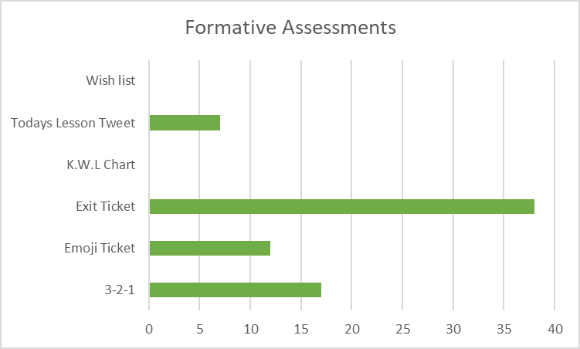
As a result, the evaluations were streamlined by choosing basic questions instead of requiring written reflections. Since the implementation of online surveys in November 2020, we have conducted 176 classes and received 74 responses through online formative assessments. Additionally, the librarians utilized a main evaluation, the class climate survey, which was completed by 708 students.
Case Study: 4
As an example of formative evaluations conducted using a link to a version of the assessments in LibForms, we collected two responses from an English 110 class of eight students, a response rate of 25%. The class task involved writing a paper regarding ethnographic research. The students were sent a link to the digital version of the tweet evaluation in the chat during the Zoom meeting. The responses were positive and provided useful insights on what aspects to continue. One student mentioned that the librarian was easy to understand, while the other stated that they had a better grasp of how to use the library's website. Additionally, while the tweets were helpful for our social media, one student included the hashtag #awesomelibrarian, and another wrote #informative. However, the low response rate is concerning.
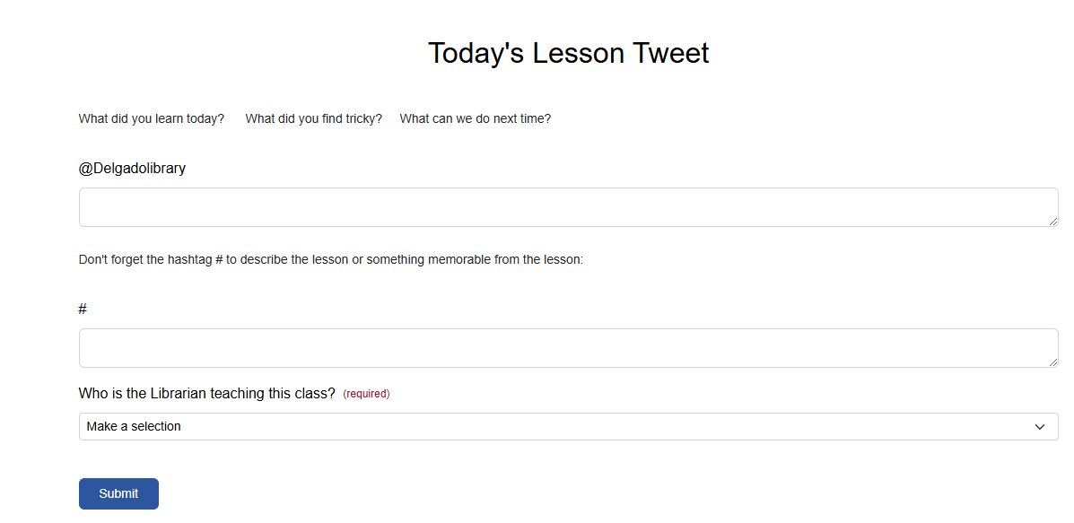
Online links were more efficient in a Zoom environment and took up less valuable instructional time than paper forms. The main challenge remained encouraging students to fill out the forms, especially when they were sent after class. Adding a link in the chat box did not increase participation, and the number of forms submitted was low.
The Use of QR Codes
By the fall of 2023, the library no longer had dedicated library instruction classrooms. As a result, librarians had to travel to a designated classroom to conduct library instruction. Online forms were not feasible since not all classrooms had computers, and print forms were cumbersome to transport across campus. While "in-class pen and paper forms may yield the highest response rates" for one-time sessions, they took too much time (Wagner, 2018, p. 30). As a result, we researched technologies such as QR codes and Microsoft Forms (Sterner, 2023) that would allow us to collect data more efficiently. In 2024, our System Administrator improved the Formative Evaluation LibGuide by creating a QR code page that links to the existing online evaluations.
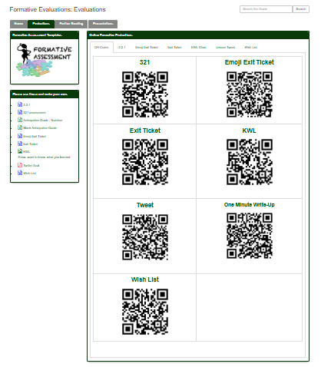
In the Fall 2024 semester, we piloted the instructor formative evaluation to a cohort of instructors who had prior library instruction sessions. First, to understand their needs, we sent an email with a QR code to instructors in the Fall 2024 semester. This short-answer survey focused on whether instructors felt the librarian adequately covered the resources and if there was confusion about the material presented. The feedback we received was positive. One useful suggestion came from an instructor who recommended allowing time for students to use the resources presented in class. It may be challenging to implement due to the limited instruction time available. The survey response rate could be improved, as it was sent to eight instructors, but only four responded. Sending a thank-you email with a link to the survey immediately after each class may improve response rates.
Next, we developed a set of questions for our Nursing Resources presentation and a separate one for an English session. The QR codes proved beneficial, as the 50% response rate from having a class scan QR codes to access the online version of a formative assessment during an in-person class was significantly higher than the response rate from posting the link in the chat for a class held on Zoom. While this rate is still lower than that of a paper form in an in-person class, the results from the evaluation given to an English 110 class demonstrated that students who completed the form retained critical information presented during the instruction session. One significant advantage of QR codes is that users do not need to spend time typing or navigating to a web form (Sekyere, 2020, p. 96). This feature saves the librarian and the students time at the end of class.
The feedback we received was categorized as a “knowledge check,” which shows that students benefited from the instruction session. They came away with a better understanding of the library, its services, and resources than before the session, underscoring the value of these instructional efforts. We found that the number of responses we received was directly related to the number of questions asked. The library knowledge survey included seven questions and took approximately two minutes to complete. Consequently, longer surveys tended to generate fewer responses.
Additionally, creating these quizzes is an effective way to assess whether students have understood the information presented during instruction. Most students feel comfortable using QR codes and typically have their cell phones readily available, reflecting current technological trends. Some students who struggle with technology will be better served with a paper form, so it's good to bring backups (Safin, 2022). Regardless of the format, selecting the right questions and motivating students to complete the quiz can be challenging.
In Spring 2025, to effectively engage students' interest in QR codes, we placed a general library instruction survey at the circulation desks. This Microsoft Form contained six questions with a comment section and took about two minutes to complete. We promoted the survey through the library's social media and Canva platforms; this did not garner much response. By individually asking students as they visited the desk, we were able to gather 41 responses, with 18 students leaving positive comments about the library and staff. One negative response alluded to the “no food or drink” policy. As expected, several students captured the QR code but did not submit their feedback, reaffirming that, no matter the format, getting students to participate can be a challenge.
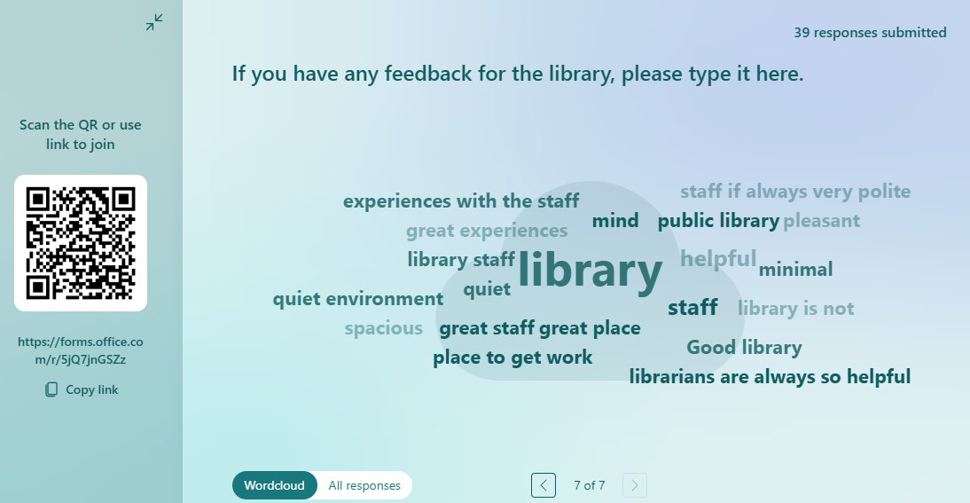
Conclusion
QR codes provide an easy method for gathering information. From the librarian's perspective, displaying a QR code on a stand is quicker for students than distributing and collecting paper forms. Furthermore, responses from online forms are automatically compiled, which streamlines the process. From the perspective of the students, they already know how to scan these codes using their phones and typically have their phones readily available.
Our journey using formative evaluations through shifting modes of instruction and across a variety of classes has had mixed results. They do provide insight into how students perceive and use the library and, occasionally, some functional suggestions for ways to improve instruction or what students would like more information about. However, response rates are low, especially in online classes. There has been some initial success with using QR codes to lead students using the library to a general survey of their library knowledge and usage, though paper forms still appear to produce higher response rates for face-to-face classes. We will continue to assess which evaluations and formats return the best results.

References
Brossard, M., Hickoff-Cresko, R., & Oberlin, J. (2014). Snapshots of reality: A practical
guide to formative assessment in library instruction. Association of College and Research Libraries, a division of the American Library Association.
Dutch Renaissance Press LLC. (2023, December 7). Welcome to Tim’s printables! Tim’s
Printables. https://timvandevall.com/
Hartley, I. (n.d.). Today’s Lesson Tweet. Pinterest. Retrieved from
https://www.pinterest.com/pin/530439662337093405
Delgado Community College. (2009, May 26). Master syllabus and course syllabi.
docushare3.dcc.edu/docushare/dsweb/Get/Document-3671/1503+Master+and+Course+Syllabus+Formats+Approved+May26+2009.doc
Orblych, T., & Dunaway, M. K. (2013). Formative assessment: Transforming education in
the library. In LOEX Conference Proceedings 2011 (Vol. 24). https://commons.emich.edu/loexconf2011/24
Safin, K., & Sterner, E. (2024, Winter). QR codes in instruction and outreach. Tips and
Trends. ACRL Instruction Section. https://bit.ly/tipsandtrendsw24
SaintT. (2017, September). Lesson plan self-reflection and evaluation. [Unpublished
document]. https://www.saintt.com/documents/2017/9/LessonPlanReflectionAssessment.pdf
Sekyere, K. (2012). QR codes in libraries: Uses and usage tracking. College &
Undergraduate Libraries, 19(1), 95–100. https://doi.org/10.1080/10691316.2012.652551
Sterner, E. A. (n.d.). Reading and assessing systematic reviews: Developing an effective
learning experience for faculty and students. NOLA Information Literacy Collective. https://www.youtube.com/watch?v=mB4MuwpRe2U)
Wagner, S., et al. (2021). Toward a thoughtful assessment practice: Using reflection to
guide library instruction assessment. Reference Librarian, 62(1), 23–33. https://doi.org/10.1080/02763877.2021.1913466

Appendix
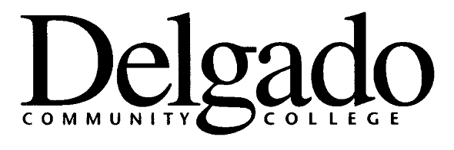

MASTER SYLLABUS
INFORMATION LITERACY

COURSE LECTURE-LAB-CREDIT and/ CONTACT HOURS: Contact Hours 1.5 to 3.0

COURSE MAXIMUM ENROLLMENT: 50
LAB FEE: __________________
SPECIAL FACILITY OR EQUIPMENT NEEDS/SAFETY RULES AND ISSUES: N/A

COURSE TITLE: Information Literacy / Bibliographic Instruction

COURSE DESCRIPTION: Provides students with practical knowledge of information literacy skills; specifically, the process of conducting information research for academic assignment and lifelong learning. Students will learn and be able to articulate and perform the research process. Library Instruction classes are taught in-person and virtual.

PRE- AND/OR CO-REQUISITES: In general, it is recommended students complete this course in their first semester at the College. College and Career Success Skills, English Composition I, and Programmatic Orientations typically require attendance in a formal session. Specialized, small-group, and/or individualized study sessions may also be used.

COURSE GOAL: Students will learn to employ and effectively use a variety of research tools to locate and retrieve information in print, electronic, media, and other formats. Students will learn strategies for searching, gathering, and organizing material. Students will learn how to properly cite materials. In addition, students will develop skills in reading comprehension and critical thinking.

STUDENT LEARNING OUTCOMES: Upon completion of this class, the learner will be able to:

- Formulate and refine potential and existing research topics.
- Analyze information needs for a particular subject.
- Conduct basic research strategies and search for appropriate materials in both print and electronic forms.
- Critically evaluate materials for relevancy and quality in relation to a given research topic.
- Locate resources on how to format and correctly cite for a research assignment.
COURSE CONTENT: The class focuses on how to find and evaluate information from print and electronic resources. Students will learn to effectively use the online catalog, and databases, to find books, ebooks and articles. Students will learn to filter items according to authority, relevance, and currency. Specialized content for subjects and programs are integrated into learning outcomes and may be tailored to specific needs.

TEXTS AND READINGS: Library Print and Electronic Resources

ASSESSMENT: There is no standard assessment (e.g. midterm, writing assignment) for the information literacy classes. An online or print survey is given to all students at the end of each class. This survey is comprised of nine questions that evaluate the quality of the library instruction as well as the information covered in the class. Additionally, students self-assess their ability to effectively locate, retrieve, and use information.

DISABILITY STATEMENT: It is the general policy of Delgado Community College to assure equal opportunity for all qualified persons. Reasonable accommodation for qualified persons with disabilities will be made provided the students have self-identified with the Office of Disability Services and have provided required documentation. Individual instructors will modify the methods, requirements, and procedures of courses and examinations appropriately to accommodate the special needs of students with disabilities, provided the academic integrity of the course or examination is not violated, and the health and welfare of all students are safeguarded. No accommodations will be made without "letters of accommodations" from the Office of Disability Services. See College Catalog for more information.

ACADEMIC HONESTY STATEMENT: Delgado Community College requires that students adhere to the highest standards of academic integrity. Students are entrusted to be honest in every phase of their academic life and to present as their own work only that which is genuinely theirs. Cheating, plagiarism, violation of test conditions, complicity in dishonest behavior, or other falsification of academic work is a serious breach of College standards.

Plagiarism is defined as any attempt to represent the work of another as one's own original work. More specifically, plagiarism is the direct appropriation of the language, thoughts, or ideas of another--either literally or in paraphrase--without appropriate notation on the source and in such fashion as to imply that the work is one's own original work.

Depending upon the nature of the case, a student guilty of academic dishonesty may receive penalties ranging from a grade of "F" for the work submitted to expulsion from the College. Such penalties may be of both an academic and disciplinary nature. Please see the College Catalog for additional information.

